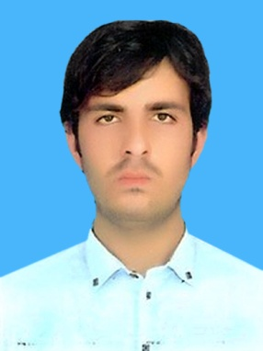

**Curriculum Vitae**

Name Zakir Khan

F.Name Khursheed Khan

Address Bar QamberKhel Sam Baba Ada

P.O. Bara Tehsil Bara District Khyber

D.O.Birth 03/03/1997

CNIC 21201­7393402-1

Religion Islam

Email [zakirnaik453@Gmail.com](mailto:zakirnaik453@Gmail.com)

Nationality Pakistani

Domical Khyber agency

Cell 0304-9651565 / 0333-5959412

Driving License LTV

Objective

To work in an organization, that offers a creative, dynamic and

Professional environment where my education, training and professional

Skill and proven abilities can be fully applied to benefit the organization and myself.

Qualification

Exam passed Board/University year marks

SSC (science) Peshawar 2013 876 /1050

F.SC (Medical) Peshawar 2015 732 /1100

B.Sc. Peshawar 2018 310 /550

M.A (Political Science ) University Of Peshawar 2021 555 / 1100

Computer Skill

DIT Techional Board Peshawar 2019 1125/1400

MS Office Microsoft Computer Institute (M.C.I) 2017

Professional Qualification

Safety Diploma osha, ( Islamabad ATSI)

Training completion certificate (Capacity Building initiative for youth of fata 2016)

First aid Responders Khyber ( Pakistan red Crescent ) 2018

Experience

2 Years Safety Assistant

3 Years’ Experience data entry Operator

Teaching

4 Year teaching Experience in Islamia Public High School.

Language

English R.W.S Good

Urdu R.W.S Excellent

Pashto R.W.S Excellent