**CURRICULUM VITAE**

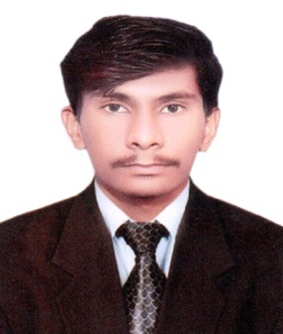**MUHAMMAD SHAHZAD**

**Address:** House No 21, Near Rangers Filter Plant,

Taj Azam Colony, Nawabshah

**Mobile no:** +92-3173601122

**E-mail:** ms4976153@gmail.com

**OBJECTIVE:**

* Looking for interesting working in concerned organization as interne for improving my field working experience.

**PERSONAL DATA:**

* Father’s Name : Muhammad Yaseen
* Marital Status : Single
* Date of Birth : 25-11-2002
* Place of Birth : Nawabshah
* C.N.I.C NO : 45402-7375994-9
* Domicile : SBA (Nawabshah)
* Nationality : Pakistani
* Religion : Islam

**EDUCATIONAL RECORD:**

**Matriculation (Science)**

* + Govt. Muslim Boy’s High School Nawabshah

B-Grade 2017-2019

**FSC Pre-Medical**

* **Govt. Boys Degree College Nawabshah**

A-GRADE 2020-2022

**DIPLOMA:**

**D.A.E Three Year Mechanical**

* Govt. Habib College of Technology Nawabshah Final Year (To be complete)

A-Grade 2019-2022

**EXTRA COURSES:**

* AUTO C.A.D Three Months (Phase Xlll-PSTW) (Szabist ZAB Tech Institute of Technical

**EXPERIENCE:**

* 01 year experience as a Auto Cad in Infinit Architect Nawabshah.
* Work on 2D & 3D Front Elevation
* One Year Experience In Data Entry For Amrdo Foundation Nawabshah Branch
* One Year Experience In (MS Office) and Ghazi Social Welfare Association Nawab shah as a Finance assistant to be continuo.

**COMPUTER SKILLS:**

* Working ability on Windows XP,7,8 & 10 , also Installation skill as well
* Software Skills
* Internet Browsing

**HOBBIES:**

* Reading books
* Playing cricket

**LANGUAGES:**

* Sindhi
* Urdu
* English