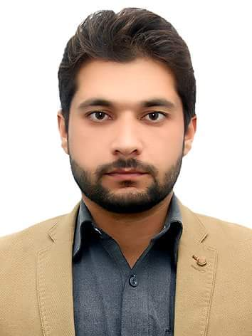

Objective

I am a graduate in Economics, seeking a position in a well reputed organization where I can exercise my educational learning to professional use, prove myself as a contributory member and become an asset for the organization.

Education

* BS-Economics (2013-2017)

University of Peshawar

* Intermediate-General Science (2013)

BISE Peshawar

* Matriculation-Science (2010)

BISE Peshawar

* Economic research Paper

Impact of electricity crisis on text tile

industry in pakistan

Experience

**Accountant:** 2 Years working as an accountant (Excel Learners Academy)

Professional Skills

* Computer Skills

Computer literate key attributes includes:

MS office (Word, Excel Power point, Access, Typing, Internet)

SPSS

Accounting(Quick book, Myob, Peachtree quantum, Tally,

Office accounting)

E-views

* Adobe Photoshop CC 2017, Google Earth, Hardware and Software, Google AdSense, Google Translate, Link din, Online advertising, Twitter account, you tuber, Operating Systems

References

Will be furnished on Request

SHAHAB UD DIN

Personal Information

Father Name: Farman Ali

CNIC# 17301-1773133-5

Date of Birth: December 29th, 1995

Nationality: Pakistani

Martial Status: Single

Contact

**Address:**

Bari lal kurti masjid lane room no.1 Ali chicken shop Peshawar cantt

**Phone:**

+92-3028805986

+92-3128080140

**Email:**

[shahab123din@gmail.com](mailto:shahab123din@gmail.com)

Languages

English

Urdu

Pashto