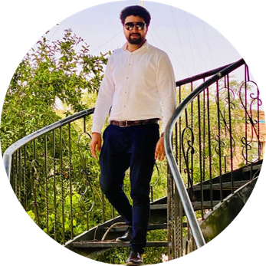  Sameer Anwar Marketer  Contact  Address  Gulabad no 1 Peshawar sadder  Phone  03138988803  E-mail  sameerkhanqureshi001@gmail.com  Skills  - Marketer( Sales, Marketing, Negotiations)  - Digital Marketing  - Canva Expert  - Social Media Management  - E-commerce Expert  - Excellent Communication Skills  - MS Office  - Content Writer  - Presenter  - Fluent English communicator | Enthusiastic, eager to contribute to team success through hard work, attention to detail and excellent organizational skills. Clear understanding of task, Motivated to learn, grow and excel in organization.  Work History  2022-04 2022-08 2022-09 2023-05 Real Estate Agent Worked in different Real Estate Projects Corporate Sales Executive(On the Behalf of Dealer) Atlas Honda Limited , Peshawar Working in the domain of Procurements and Financial institute  2021-2023 Initiate my own Start-ups - Being Classie - Elegencia Explorers  Education  2013-06- 2015-06 Matriculation: Science Peshawar Public School And College Peshawar `  2015-07 - 2017-07 F.Sc : Pre-Engineering F.G Degree College Peshawar - Peshawar Cantt  2017-07 - 2022-04 BBA (Hons): Marketing Sarhad university of information and technology Peshawar  2022-09-active MBA (Marketing)  Institute of Management Sciences Peshawar (only research remaining)
.

