SYED SALMAN ALI
todayhopee2004@yahoo.com Cell: 03120034134-03040873998

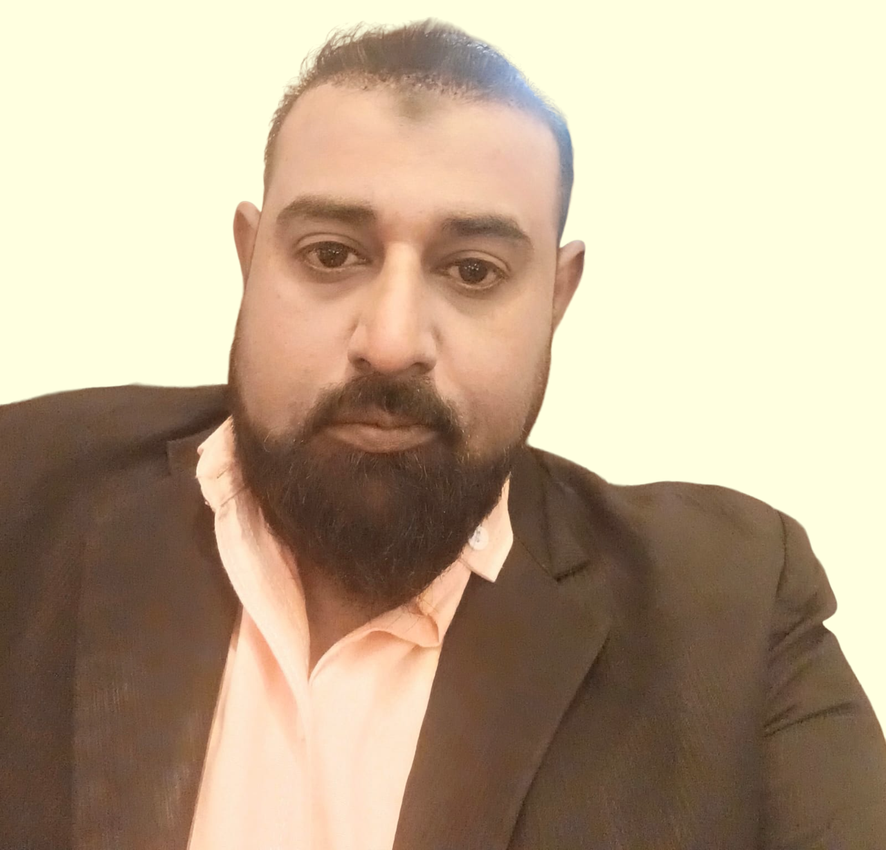

Objective
Im proactively seeking a challenging and creative role in Sales/Marketing I am a successful business professional with a proven track record of business growth and restructuring of multinational corporations. I would bring my tenacity and penchant for success to your organization in the capacity of the Territory Sales Manager. As such, here are the main areas of expertise I will bring to your company: A strong commitment to the Market, having contributed my talents in the marketing assigned territory category in a variety of roles and capacities. Solid marketing background and the savvy to implement, understand and troubleshoot marketing operations while achieving business growth and increased market share resulting in profitability. The entrepreneurial spirit, adaptability, and knowledge that will bridge essential relationships to achieve business success More than 12 years of strategic, forward-thinking initiatives that transcend the current state of the company to deliver profitability and achieve growth. My MBA degree and leadership positions held I a volunteer capacity with various non-profit organizations further bolsters my qualifications and aptitude to complete the job requirements..

Personal Profile
- Father Name: Syed Mohammad Ibrahim
- Date of birth: 18 march 1986
- N.I.C No: 41304-8169936-5
- Marital Status: Married
- Address: House # 71 kohsar phase 02 Latifabad Hyderabad.

EDUCATION & CREDENTIALS

MBA (MARKETING) UNIVERSITY OF SINDH JAMSHORO

B.com Govt: Ghazali College of Hyderabad Sindh
Intermediate Sindh board of technical education of Hyderabad Sindh
Matriculation Govt Allama Iqbal High School Latifabad Hyderabad

DIT  from skill development council
(Waiting result)

- Introduction to Information technology
- Office automation (MS-office)
- Microsoft Excel
- Microsoft Word
- Microsoft PowerPoint
- Microsoft Outlook
- Web designing (HTML, DHTML, Adobe Photoshop, macromedia flash)
- Typing short hand courses certificate
- Sindh worker welfare boards

Career Profile & Achievements
.
A dynamic professional with more then12 years of experience, worked in different areas of pharmaceutical company & Electronic Electric market company, and mobile industry and marketing, carrying out sales and marketing activities, promotion tools to be implement at right place / right time always seek for opportunities and ready for challenges whenever sales barriers occur. An ambitious, optimistic and exceptionally knowledgeable, creative and result oriented individual with an impressive background in meeting and exceeding sales objectives of the assigned areas, by promoting and selling company product through professional sales techniques.

Fast Cables LTD- the national Quality Brand of cables industry top sellers of electric market ranking in Pakistan
Nokia (Icon consultant)- HMD Global appoints Mother to lead worldwide launch of its new Nokia branded mobile phones
MRM TRADERS - is among the leading larges SAMSUNG-SENCOR ELECTRONIC Distribution of Pakistan.
AGP Pharmaceutical (inter business B Group) is among the leading pharmaceutical companies of Pakistan and different country of the World. Involved in over-the-counter activities ranging from marketing & sales.

Core Areas of expertise: Excellent understanding of Market and Product life cycle from obtained from these companies.

Selling Skills ability and done short course from fast cables-HMD global and AGP pharmaceuticals trainer for lead Generation business relationship-management customer service relationship-building teamwork communication sales Management-sales presentation new business development & Selling Skill and marketing activity.
- Remarkable ability to craft a solution with appropriate products and services that meet business goals based on customer requirements
- Remarkable knowledge of implementing the policies and procedures down the line
- Profound ability to develop positive and supportive relationships with colleagues; internal staff and management
- Exceptional ability to demonstrate professional skills for verbal and written communication
- Proactive follow-up skills with customers, internal staff and management
- In-depth ability to present to large groups and individuals including customers; colleagues and management
- Proven confidence, enthusiasm and a desire to excel
- Strong ability to be a team player
- Great persistency and ability to negotiate with professional skill and expertise
- Excellent listening skills and ability to value other opinions.
- In-depth ability to maintain territory and mandatory reports as appropriate.

Highlights of Key Accomplishments

- In first day, utilities my experience and continue achieve the sales target of first month,
Professional Experience & Achievements

FAST CABLES PVT LTD august, 2021 to till date
Assistant Sales Manager

Promoting the company range of electric cables to Hyderabad and all interior Sindh including Sukkur Larkana electric (Trade Networking) market,
Territory
All interior Sindh Electric market including Sukkur Larkana

Key Role & Responsibilities
- FIRST DAY I AM WORKING IN HYDERABAD BRANCH.I STARTED BUSINESS FROM ONE TRADE DEALER TILL NOW Sixteen DEALERS IN HYDERABAD AND Twelve OFFICILY DEARES OF COMPANY GIVING ME BUSINESS IN
- Outstation market dealer, monitoring Sales out flow and reviewing work methods and procedures
- Suggesting plans and programs boost the sales of the Fast cables in trade.
- Preparing periodic reports with respect to the departments Managed territory and sales by identifying different type of specialty of Dealers to meet the challenging targets.
- Coordinate with dealer/distribution to ensure availability, visibility and liquidity.
- Develops and maintain an efficient and effective customers and effective communication in order to maximize Sales and achieve planned Market shares.

Nokia mobile (Icon consultant) June, 2016 to 01 July 2021
ASM South
Promote the companies a range of Nokia Mobile keypad and android phone to Hyderabad mobile Market & out, station mobile market,

Territory
Nawabshah belt mobile market Mirpurkhas belt mobile market Badin belt mobile market and Thatta belt mobile market

Key Role & Responsibilities

  - Played a key role in increasing the sales and three time more than 200% continually monthly sales closing done, top one in all Pakistan ASM in Nokia mobile company
  - Participating in the development of the department's work plan; distributing and following-up on Hyderabad &
  - Outstation market dealer, monitoring Sales out flow and reviewing work methods and procedures
  - Suggesting plans and programs that strive to boost the sales of the Nokia Mobile keypad and android phone.
  - Maintaining records on data, such as sales records, items sold, and representatives records to ensure compliance with sales targets and incentives Preparing periodic reports with respect to the departments amount collection,
  - Managed territory and sales by identifying different type of specialty of Dealers, and different pockets of sales to meet the challenging targets.
  - Coordinate with dealer/distribution to ensure availability, visibility and liquidity.
  - Develops and maintain an efficient and effective customers and effective communication in order to maximize Sales and achieve planned Market shares.

MRM TRADERS JANUARY 2016 To May 2016
SALES EXECUTIVE
Promote the companies a range of Sencor, Samsung products to electronic & crockery market

Territory
Gull center electronic market, fojh dari road electronic market, station road electronic market, pakka Qila crockery market Latifabad 08, 07 market,

Key Role & Responsibilities
- Participating in the development of the department's work plan; distributing and following-up on electronic, crockery market dealer, monitoring work flow and reviewing work methods and procedures
- Suggesting plans and programs that strive to boost the sales of the Sencor MRM traders.
- Preparing periodic reports with respect to the departments amount collection achievements to be submitted to MRM trader account.

AGP PHARMACEUTICAL PVT(ltd) Karachi MARCH, 2011 to January 2016
SENIOR sales promotion officer
Promote the companies a range of Rigix products to area of doctor and medical store

Territory
Hyderabad, Saddar, LMCH, Latifabad, Qasimabad, Kotri, Tando Mohammad Khan, tando Allayer, Matli, Gularchi, Tandon Bhago, Thatta, Badin, Nindo, Khoski,
Mirpurkhas belt thata belt & badin belt.

Key Role & Responsibilities
- Achieving Sales Target as SSPO and contribution is concern.
- To present and promote the companies a range of pharmaceutical hospital, specialists, pharmacy and Chemist.
- Organize medical seminars and public forums.
- Build close ties with the decision-makers of main hospitals/doctors to ensure a continue usage of company's products.
- Foster strong relationship with specialists, doctors, and chemists to encourage the use of company's products.
- Maintaining records on data, such as sales records, items sold, and representatives records to ensure compliance with sales targets and incentives
- Managed territory and sales by identifying different type of specialty of doctor and different pockets of sales to meet the challenging targets.
- Shared new ideas in zonal cycle meetings that resulted in zonal sales increase.
- Coordinate with dealer/distribution to ensure availability, visibility and liquidity.
- Ensures that the sales targets for all brands / products are met as per action plan.
- Provides timely feedback on market situation, sales outlooks, competitor's activities, product pricing.

Multi Lingual

- Fluency Oral communication in English, Urdu Sindhi

