Sajid Khan

Contact

**Address:**

* Distt: Khyber, Tehsil Landikotal, Khuga Khel, Fatmi Khel

**Phone:**

* +923361884948

**Email:**

sajidkhansmc2016@gmail.com

**Nationality:**

* Pakistani

**Date of Birth:**

* 16/03/1998

**CNIC:**

* 21203-4862273-3

**Domicile:**

* Distt: Khyber

**Religion:**

* Islam

**Gender:**

* Male

**Material status:**

* Unmarried

**Languages**

* English, Urdu, Pashto

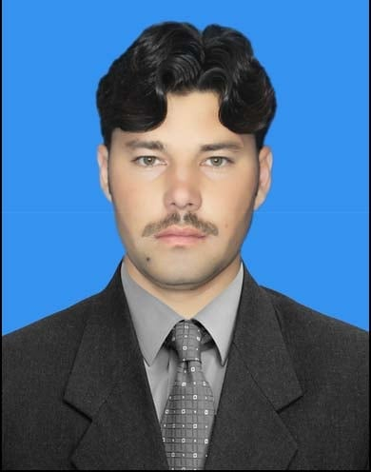

Summary

Strong in design and integration with intuitive problem-solving skills. Proficient in JAVA, ANDROID, HTML, JAVASCRIPT, CSS and SQL. Passionate about implementing and launching new projects. Ability to translate business requirements into technical solutions. Looking to start the career as an entry-level software engineer with a reputed firm driven by technology.

Skill Highlights

|  |  |
| --- | --- |
| * HTML * Android * Java * JavaScript | * Asp.net * SQL * CSS |

Experience

* 3 years of Teaching Experience in private School Landi Kotal.
* 2 years of computer operator job at Abasyn University Peshawar.
* 1 years of computer operator at new Shinwari iqra education system

Education

**Degree Institute/Board division year of passing**

Matriculation BISE, Peshawar 1st 2014

Intermediate BISE, Peshawar 1st 2016

Bachelor (CS) Abasyn university Peshawar 2nd 2021

Certifications

* DIT (Diploma in information technology)

Hobbies

* Cricket
* Watching TV
* Newspaper