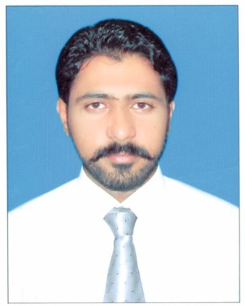Saad waseem

 Peshawar, Khyber Pakhtunkhwa.

**+92-345-9050422**

reflex_rays@hotmail.com

**saad.waseem72**

**CAREER**

**OBJECTIVE**

**TARGET**

**POSITION**

**PROFESSIONAL SUMMARY**

**EDUCATIONAL BACKGROUND**

To be a dynamic and versatile finance professional, being able to work under various work environments and provide professional advice or service to client or employer.

My aim is to obtain a senior or mid-level management position in an established and reputed organization in the field of Auditing and Accounting.

I started my professional experience with International Multiple Group Of Company (IMGC) Associate Industries Of Limited (AIL) Shama Oil Mills Nowshera, as an Internal Audit Officer form (Sep 2012- till date I am working).

I did my MSC Finance from Institute of Management **|** Sciences Peshawar (2010-2012) and BBA Hon’s in finance from City University of Science & Technology Peshawar (2005-2009).

I am working as **Senior Manager Internal Audit** at Associated Industries Limited (Shama Ghee & Cooking Oil Manufacturers).



* Master Of Science In Finance (2010-2012)
* Institution Of Management Science (IM|sciences)
* 3.70 CGPA
* Bachelor Of Business Administration (2005-2009)
* City University*of Science & Information Technology,*Peshawar
* 2.81 CGPA (Equivalent MBA)
* Diploma Of Commerce (2003-2005)
* Khyber college of commerce
* Matric In Science (xxx-2003)
* St.John Vianney High School

**PROFESSIONAL EXPRERIENCE**

***AIL*** *is part of* ***International Multi Group of Companies (IMGC)*** *which has diverse portfolio of investment i,e manufacturing units of* ***Ghee and Cooking Oil*** *at Nowshera, Multan, and Karachi and one* ***textile unit*** *at Jehlum,* ***supply of food and non-food items*** *to* ***UN Agencies and International NGOs****, import of* ***Hollywood & Bollywood****films and their distribution all over Pakistan.*

**INTERNSHIP**

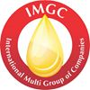**Associated Industries Limited**

**Senior Manager Internal Audit**

**Sep 1ST 2012 – Present**

Associated Industries Limited (AIL)is a public limited company involved in production & sale of **“Shama” Ghee and cooking oil**. AIL is the **Market Leader** of Ghee & Cooking Oil in **Khyber Pakhtunkhwa.**

**Being Audit Senior Manager,** I have been performing following responsibilities;

* Overall direction and supervision of Internal Audit Department.
* Reviewing Internal Controls in various departments, identifying control weaknesses and non-compliance with established control policies and procedures and reporting to Executive Board.
* Performing various audit assignments as and when instructed by Executive Board.
* Pre and Post Audit of the transitions made by Management and reporting observations to Executive Board, if any.
* Take part in Monthly Stock count of various inventories i,e Finished Goods, Raw Materials and Store & Spares.



**Finance Department (Civil Secretariat)**

Trainee Assistant Manager

January 2010 till February 2011

* Work on budget section.
* Work on fund section.
* Work on development section.



Pakistan Telecommunication Company Limited

Account officer

July 2009 till august 2009

* Working as a customer services Representer (CSR)
* Solving customer Bills problems
* Work on revenue section 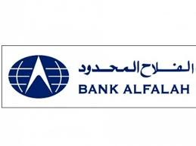

Bank Alfalah Limited

Trainee

1st to 22nd august 2008

* Operations
* Trade Finance (Foreign Trade) – Export, Imports
* Credits
* Consumer Finance – Car Finance
* Customer Services

**Achievement**

**SKILLS**

**LANGUAGES**

**OTHER INFO.**

**PROFESSIONAL REFERENCE**

* **Research Paper**: First Half-0f-A-Month Effect in Stock Returns: Evidence from KSE 100-Index Pakistan.
* Merit scholarship at IM|sciences.(IM|Sciences)
* Member of Proctoroil Board.(IM|Sciences)
* President of Tour Society (City University)
* Member of Organizing Society (City University)
* Proficient IT skills in Microsoft office (Word, Excel and PowerPoint)
* Computerized Accounting, Foxpro, PeachTree and Quick books.
* Ability to work in a team and relate to people at all levels.
* Excellent timekeeping and organizational skills.
* Proficient in Report Writing and Presentations.
* Fluent in **English, Urdu, Pashto and Hindko.**

**D.O.B** **:** December 19th 1986

**Nationality** **:** Pakistani

**Available to Join** **:** One (1) Month Notice Period

**Mr.Irfan Thair**

General Manager (F&A) at **Associated Industries Limited**

**Irfan_tahirs@yahoo.com**

**Mr.Muhammad Imran**

Chief Manger (F&A) at **Associated Industries Limited**

**Shamaghee.imran@gmail.com**