**CURRICULM VITAE** 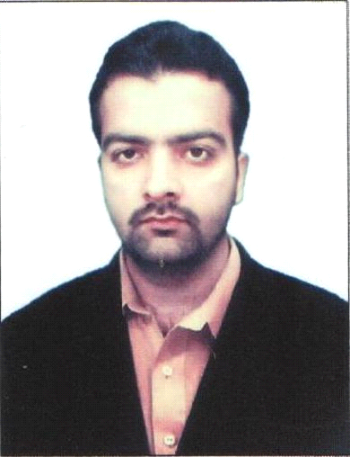

Objective.

My objective is to get the highest result from my skills and get a reputable position in a request organization and take the Organization in a leading position.

Personal Information:

Name Kamran Ahmad

Father Name Asif Khan

Date of Birth 02-05-1987

NIC 17301-3250637-5

Religion Islam

Domicile Peshawar

Nationality Pakistani

Language Urdu, English, Pashto

Marital Status Single

Contact 0321 5770762

g-Mail [kamran251987@gmail.com](mailto:kamran251987@gmail.com) Address Kanday Payyan, Landi Arbab ,Peshawar.

Academic Record:

BSc: Computer Science from Islamia Degree College Peshawar.

FSc: (Computer Science) Board of Intermediate and Secondary Education Peshawar.

Matric: Government High School Landi Arbab, Peshawar.

Computer Skills:

Microsoft Certified IT Professional **(MCITP)** Certified.

Cisco Certified Network Associate **(CCNA)**.

Microsoft Certified System Engineer **(MCSE)**.

Wireless networking

Computer Hardware & Service Technician Certificate.

Auto Cad.

Graphic Designing (Coral Draw, Inpage, Adobe Photoshop).

Internet & E-Mail.

Work Experience:

Computer Operator Water & Sanitation Services Peshawar (WSSP), (till date).

Responsibilities:

* Sending and Receiving files on FTS, File Tracking System.
* Preparation & composition of all draft of the office.
* Preparation of the Daily Attendance report of sanitation staff & Water supply staff of the Zone-C.
* Preparation & compilation of the RTS (Right to Services Act) data Report.
* Data entry of all operational system of Zone-C (Fleet, Trips of dumps & POL consumption).
* Maintain office files & Dairy dispatch system of the Zone-C.
* Maintain the Generator Log Book.
* Supervision & recording of complaint cell information & dissemination of information to concerned Chief Municipal Inspector, Municipal Inspector, & Supervisor.
* Prepare data management of SWM & WS operation of Zone-C.

Computer Operator SRSP, Swat on contract.

Computer Operator PTCL .Peshawar on contract.

Computer Hardware Engineer Nushad computers on contract.

Scope of work:

I have experience in computer hardware, Repair & Installation and currently doing job in Gul Haji Plaza, Peshawar. (Part time job)

Five month experience in PTCL as operator.

Professional Skills:

I am motivated & goal oriented person.

Ability to work under pressure.

I take my work as challenge.

Extra Curricular Activities:

Gardening

Internet surfing

Reference: Reference will be provided on demand.