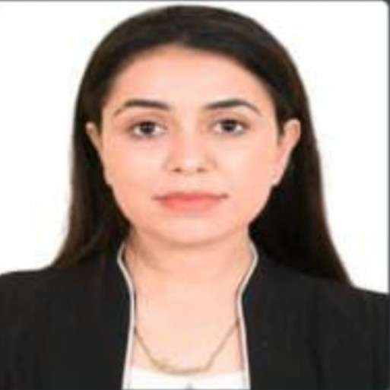

TAMANNA

MIRZA

+92332-4094001



Tammanamirzakhel@gmail.com

→

Muhallah Sheikhan Garhi Qamar Din, Ring Road

✶

OBJECTIVES

Intend to build a career in a fast -spread leading corporate which will allow me to explore myself fully by challenging my skills and o er professional growth while being resourceful, innovative and exible.

# Internee

At Khyber Teaching Hospital - Peshawar

Working as an Internee at KTH Peshawar

# Worked

At Hospital & BHU’s

Worked with Momentuem on Focus Group Discussion

# Internee

At Combined Military Hospital - CMH Peshawar

Worked at CMH Peshawar as Internee

# Donor & Organizer

At JZT Thalassemia

Worked in school

At The educator school Peshawar

|  |  |  |  |
| --- | --- | --- | --- |
| LANGUAGES   Urdu  Pashtu Expert Expert   English  Intermediate  PERSONAL INFORMATION | INTERESTS  Reading Books  Adventure |  | Gymnasium |
| Father's Name Mirza Khel | Date Of Birth | 11/12/2001 |  |
| Nationality Pakistani | Religion | Islam |  |
| Marital Status Single | National ID Card | 1730190877562 | |

Working as a Member at JZT Thalassemia

QUALIFICATIONS

SKILLS

-

MSc Psychology

From University of Peshawar

BA Psychology

From University of Peshawar

Secondary School Certificate Examination

From Jinnah College for Women- University of Peshawar

# Matriculation

From Peshawar Model School

Technical Skills

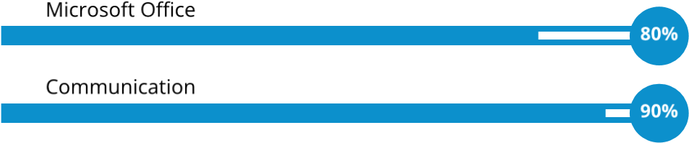Management Skills

☞ Supervision

# REFERENCES

Request On Demand