**SAAD UR REHMAN**

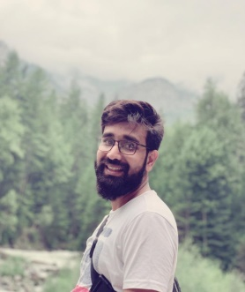

USMANIA ROAD, STREET NO 3, TEHKAL BALA, UNIVERSITY ROAD PESHAWAR.

🖂: saadimani007s@gmail.com

🕿: +923355049499

**OBJECTIVE**

An organized and independent self-starter, able to effectively coordinate multiple tasks to accomplish projects with timeless and creativity and stay calm under pressure.

**EDUCATION**

**MASTER IN BUSINESS ADMNISTRATION (Marketing)**

Iqra National University Peshawar

**BACHLOR OF COMMERCE**

National collage of Management sciences

**DIPLOMA IN COMMERCE**

National collage of Management sciences Peshawar

**Secondary School Certificate**

**Pakistan Public School**

**Group; Science**

**SEMINARES, FIELDWORK AND THESIS**

* Attend the Carrier Planning workshop in collage.
* Attended 10 days NCMCM camp 2008 organized by WWF & Wild life Pakistan
* Participated in number of Seminars organized by Humdard Nonehal Assembly during school life.
* Participated in co-curricular activities in school & collage.

**COMPUTER SKILLS**

* Office Automation
* Adobe Photoshop
* Hardware
* Quick Book
* Internet Surfing

**LANGUAGE SKILLS**

* English - Well versed in Reading, Writing and spoken.
* Urdu - Well versed in Reading, Writing and spoken.
* Pashto - Well Spoken

**JOB EXPERIENCE**

* 4 years Experience at Ocean developers and Consultant (DHA Peshawar & Multan Authorized),in Sales & Marketing (Digital Marketing), Plots Transfer and NDC's Applying.
* 1 and a half Year worked in Trade International Logistics Peshawar as a Cargo & Custom Clearness Officer for Export at Peshawar Airport.
* 4 months worked in Nokia Promotion Project with Heyworth as a Senior Anchor person.
* 2 month worked in Samsung Promotion Project with Heyworth as a Supervisor.
* 6 months worked with P&G.
* 2 month worked in Zong Promotion project as an supervisor.
* 3 month in Engro Foods,Olpers milk as an Anchor person.
* 2 month worked in Coca-Cola as an supervisor.

**PERSONAL INFORMATION**

**Date of Birth:** 30 January, 1995

**Father’s Name:** Ehsan ur Rehman

**Religion:** Islam

**Nationality:** Pakistani

**Marital Status:** Single