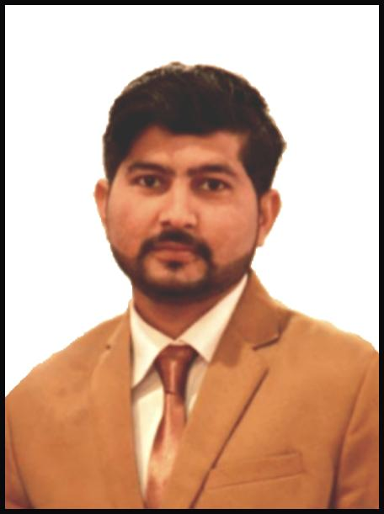 Saif Ur Rehman

**Add:** H No 37, Street 2 Phase 4, Labour Colony Site area Kotri

District Jamshoro

**Contact:**  0301-3600812 / 0300-3001761

|  |
| --- |
| **CAREER OBJECTIVE** |

Utilize my abilities and talent in the dynamic challenging & mission oriented where my skills can have an impact, resulting in the growth and productivity of an organization

|  |
| --- |
| **Personal information** |

* Father's Name Liaquat Ali
* Date Of Birth 22/02/1993
* CNIC 41204-1944067-3
* Domicile Jamshoro
* Religion Islam
* Nationality Pakistan
* Marital Status Married

|  |
| --- |
| **EDUCATION** |

**Matriculation from B.I.S.E Hyderabad Grade “A” Marks (596/850) in 2010**

**Intermediate from B.I.S.E Hyderabad Grade “B” Marks (713/1100) in 2012**

|  |
| --- |
| **Working experience** |

* Worked 02 year **Meko Textile Mill No 2 Kotri** as a **Production Clerk.**
* Worked 01 Year **Amin Textile Mills Kotri** as a **Packing Supervisor**.

|  |
| --- |
| **Computer Skills** |

* Office Managements
* Internet

|  |
| --- |
| **language** |

* English
* Urdu
* Punjabi

|  |
| --- |
| **reffrences** |

* Will be furnished on demand