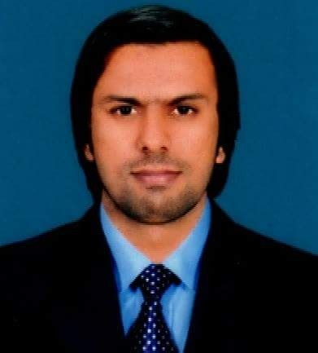

**ABOUT ME**

ZOHAIB NASEER

**BRANCH MANAGER**



**ACADEMIC EDUCATION**

**L.L.B 2016-2022 2016-2020**

**Islamia University of bhawalpure**

# B.COM 2003-2005

University of the Punjab Lahore

# 2003 - 2005

In B.Com. I Learn commerce and business. With doing b.com.,I learn basic to advance accounting,

management and different business laws which is helpful to me in my profession

# F.S.C

Board of Inter mediate and secondary Education Lahore

# 2001 - 2003

FSc. Pre-Engineering provide me a multifaceted exposure and education to basic scientific enquiry

field. Which is helpful for me in multi tasking.

Matriculation (Science)

Board of Inter mediate and secondary Education Lahore

# 1999 - 2001

The Matriculation Program takes me from diverse backgrounds an early introduction to learning skills that facilitate success me in education.

I am administering an organization and a

group of staff. These courses are tailored for all levels of office workers. My duties are providing training, developing strategies, setting goals for the team, listening to the team's feedback, and creating reports for the ap propriate personnel. I have good interpersonal and communication abilities, self motivation, and managerial experience.

C.C.S



**CERTIFICATIONS**

Lasani I.T. College Raiwind Road Kasur

I successfully complete the course with 70% marks A Grade.

# 2011 - 2012

Spoken English



**CONTACT ME**

Westminister International Language Center

I successfully complete the diploma with A Grade.

# 31/01/2009 - 31/03/2009

Phone E-Mail Address

+923004949049

[Zohaib.naseer@gmail.com](mailto:Zohaib.naseer@gmail.com)



**WORK EXPERIENCE**

617 R-1 Katcheri Road Kot Ghulam Muhammad Khan Kasur

Father Name CNIC

Date of Birth Religion Martial Status Domicile Nationality

Interpersonal Creative Analytical Team Work Communication Presentation Supervision Leadership

Naseer Ahmad 35102-8836560-5

07-11-1985

Islam Single

Kasur (Punjab) Pakistani





Branch Accounts Manager (Jazz Franchise) 2007 to continue

Jazz Franchise Kasur (7116) Saleem Communication



**PERSONAL INFO**

Timely and effective communication of targets and its monitoring/reporting

Leading the team of Dos Recovery And achieve targets

DOs Retail staff motivation and training sessions to ensure that they are well versed with product knowledge, systems and procedures

Managing and Handling Book keeping (Journal Dr + Cr Ledger)

Preparing Monthly Salary Sheets, Cash Payments Vouchers and Statement of Accounts. Maintaining Purchase & Sales Accounts Statement.

Financial Matters Including Banks, Insurance Leasing & others supplies Payments. Ensure that incidence of taxation on the company is minimized and the company discharges all tax obligations with in time.

Carry out any other duties as assigned by the C.E.O & Board of Directors..



**SKILLS**

Customer Care Representative (Jazz Franchise) 2006 - 2007

Jazz Franchise Kasur (7387) Hafiz Communication

Customer Care Maintain Daily Reports

Maintain all Official works Relating Customers

Customer Services Operator (Ufone Franchise) 2005 - 2006

Ufone Franchise Kasur (UFR0001)

Customer Care Maintain Daily Reports

Maintain all Official works Relating Customers

# 



**LANGUAGES**



**INTERESTS & HOBIES**

Urdu



English