**Contact:**

**Objective**

Seeking a challenging position in a progressive with an aim to contribute positively towards the achievement of tis objectives to the best of my capabilities and to develop and improve my professional skills.

**Work History**

**2022-02 Internee, Banking Operations**

* 2023-04 *MCB Bank, Karak (kpk).*

2021-06 **Accountant Trainee**

* 2022-03 *Superior College Chokara Karak,(kpk)*

**Education**

2019-08  **Finance, Bachelor of Business Administration**

* *2023-10 Khushal Khan Khattak University Karak, PK*

*Obtained CGPA: 3.58*

*Total CGPA: 4.00*

*2017 Shaheen Children Academy and Collage of Sciences*

*2019 Karak (Kpk).*

*Obtained Marks: 881*

*Total Marks: 1100*

**Projects**

2023-03 **Group Leader**

* 2023-05 *Analysis of coin offers*

**Awards**

2019-08 **Ehsaas Scholarship**

2019-12 **Merit Scholarship**

2019-10 **Fauji Foundation Scholarship**

**Courses**

2023-09 **Customer Services**

2022-06 **Kamyab Jawan Programme**

**Certificates**

2019-08 **DAE Mechanical**

2022-04 **MCB Bank Internship Certificate**

2023-03 **Kamyab Jawan Programme**

2023-03 **Customer Services**

**Hobbies/Interest**

*Reading Dawn & BBC News*

*House hold Management*

*Writing*

*Hockey, Football, Cricket*

**References**

**HOD DR. Siraj Ud Din**

Department of Management Science in KKKUK

**Personal Info**

**AFAQ ULLAH**

**Accounting & Finance Officer**

**Father’s Name**

Muhammad Roshan

**CNIC**

14202-0421357-7

**Email**

[afaqullah315@gmail.com](mailto:afaqullah315@gmail.com)

**Cell**

03429497704 / 03182549527

**Address**

Hakeem Khel P/O Dabb Bago Khel, Tehsil &

District Karak

* Computer
* Digital Marketing (Basic)
* Financial Management
* Accounting
* Islamic Finance
* Party and Event Management
* Leadership
* Financial monitoring and forecasting
* Customer Relationship Management
* Microsoft Office
* Database Management
* Pushto
* Urdu
* English
* Chinese (HSK2)
* Arabic (Basic)

**Hobbies**

* Reading Dawn & BBC News Paper
* Cricket
* Hockey
* Football

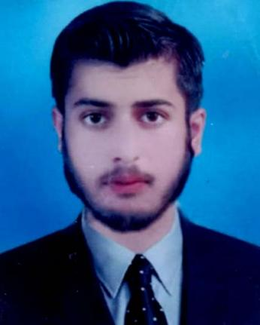

**Address:**

**Software**

**Languages**

**Skills**