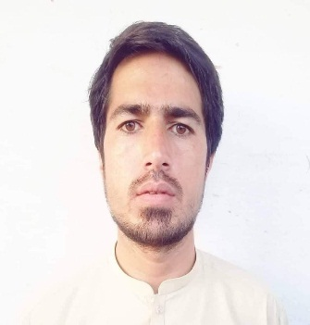

**ABID AFRIDI**

**Bachelor in economics**

**Contact No**: **+92 3009040184/ +92 3338131330**

**Email**: abidafridi1313@gmail.com

**Current Work Location: Pamir filling station**

# Academic Qualification

* **Bachelor studies in Economics** (2016-2020)University of Peshawar, Pakistan
* **Intermediate in Science**  (2014-2016) Govt. degree college Peshawar, Pakistan
* **Diploma information technology** (2017-2018) KPK board of Technical Education Peshawar, Pakistan

# Work Experiences

**Data Entry Operator.** 2017-2018

* Sorts Documents, Preparation, compilation,

**Sale Manager and Marketing. Peshawar furniture showroom** (2018-2020)

* providing guidance
* training and mentorship
* setting sales quotas and goals
* creating sales plans, analyzing data, assigning sales territories

**Operational Manager. Pamir filling station** (2020…..)

* Day-to-day operations, which include inventory, employee scheduling, hiring and training, ordering and receiving supplies and offering promotions.
* Create and meet budgets, maintain pumps and fuel supply and regularly report to company executives.

# Professional Skills

**Creativity**

I am having the ability to “think outside the box” and come up with new ideas, concepts or designs.

**Sales**

I am an excellent sales professional, demonstrated in my previous role as a Sales Manager where I exceeded my sales targets by at least 25% for six consecutive months.

**Computer skills**

I have good experience in MS office (words, Excel, database, ppt)

**Communication skills**

I have confident communication skills as giving feedback proposal to senior management.

**Good in customer relationship.**

I have good customer relationship record in my previous jobs.

Page **2** of **2**