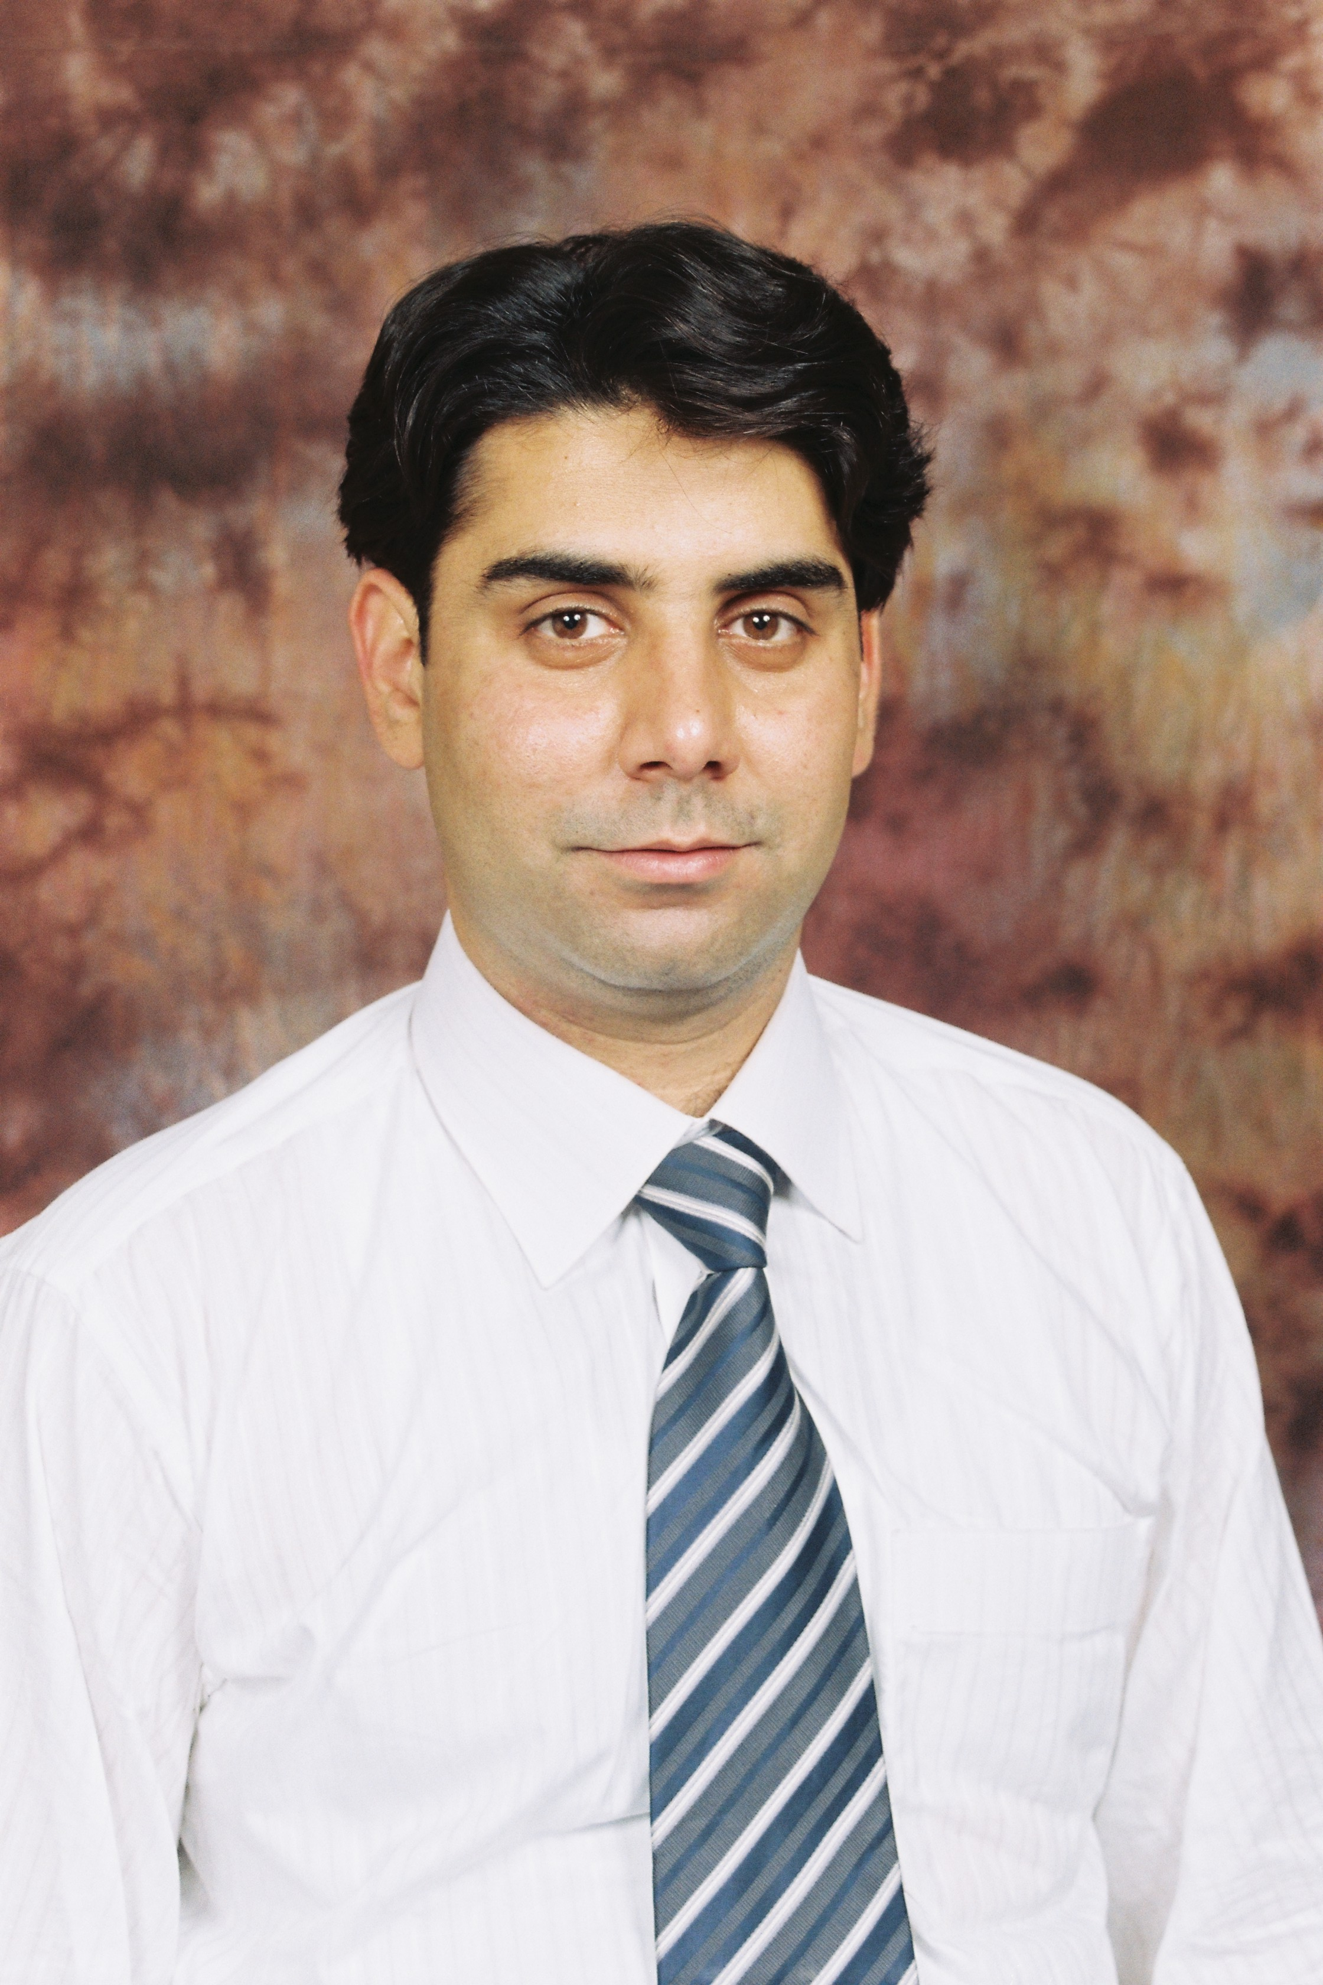
ZEESHAN PERVAIZ Age: 40 Years Residence #: +92(0)912321236
Cell#: +92 (0) 332 922 3195 email: Zeeshanpervaiz066@gmail.com

I am decisive and compassionate individual with over 16 years of progressive responsible experience in finance, budgeting, administration, logistics, Procurement and related fiscal work in development sector. Inspirational and practical team-player or potential leader managing diverse responsibilities simultaneously in fast-paced and time-sensitive situations. I see myself to be at a management level position contributing positively to improve the situations.

CAREER OBJECTIVE:
Seeking a highly challenging, technical and rewarding position in an international organization working for the social and economic development of the proletariat, where I can add value to the system through hard work and dedication for tangible prospects of career growth.

QUALIFICATIONs:
- 2004 - Masters in Commerce (M.COM) - from University of Peshawar
- 2003 - Bachelors in Commerce (B.COM - Hons) - from University of Peshawar
- 2002 - Bachelors in Commerce (B.COM) - from University of Peshawar
- 1999 - Diploma in Commerce (D.COM) - from Board of Technical Education

PROFESSIONAL EXPERIENCE:
Working experience with BEFARe (NGO) as Assistant Manager Finance from 2006 to 2022 and currently working with PHA (Public Health Association) NGO as a Manager Finance. My major expertise in Finance but also in the following field of work.
Finance.
- Routine accounting Functions according to organization / donor’s standards, such as Execution and recording of all financial transaction, ledger/account maintenance, cost analysis, reconciliations, inventory control and keep a check on project expenses according to budget line. Develop and revise budgets of all running and proposed components and Prepare financial reports through analysis of operating statistics and/or financial data.
- Monitors funds and expenses for Organization’s accounts; ensures expenditure control and compliance with funding and reporting requirements, organization’s policy, and generally accepted accounting principles (GAAP).
- Satisfactory implementation of generally accepted accounting principles and to make sure that financial system and documents are in compliance with laws, standards, organization’s policy, donors requirements
- To represent the project and Administration and Finance unit to donors and other agencies as and when required and helping the external Auditors in audit process by giving them necessary data required for audit process.
- Preparation of Reports, for cost-benefit calculations, crosschecking for important planning activities, to support strategic analysis and recommendations to support operations and other managerial decisions.
- Calculation and verification of taxes and dealing with tax consultants and government authorities.
- Design, develop and implement changes to financial policy, procedures, reporting and management system which are subject to frequent modification and to give insight to the management in finance and organization related issues and to overall coordinate and look into the support departments of the organization.
- At a time, coordinating, controlling, financially and administratively, 12 offices in four provinces, all across the Pakistan. Preparation of payroll of approx. 950 staff members.
- Approx. PKR 3.5 Million Payroll,(with allowances, deductions, EOBI & Income tax) computation and preparation in aggregate for 900+ including Afghans, staff spread across all over Pakistan in 12 locations for UNHCR funded project.
- Worked voluntarily in Refugees camps and during the retrenchment benefit of more than 2500 Afghan staff to distribute more than PKR. 120 million.

Grants/ Budgeting
- Designed grant programs & determined funding needs & opportunities. Reporting to the board of directors to coordinate and engaged with grant writers.
- Identify support agencies & Optimizing the grant administration process.
- Manage timelines and deliverables. Prepared and monitor budgets &Tracked grant applications.
Administration.
- Supervised the day-to-day operations of the administrative department and staff members.
- Hired trained, and evaluate employees and taken corrective action when necessary.
- Developed, reviewed, and improve administrative systems, policies, and procedures.
- Ensured the office is stocked with necessary supplies and that all equipment is working and properly maintained.
- Worked with the accounting and management teams to set budgets, monitor spending, and process payroll and other expenses.
- Planned, scheduled, and promoted office events, includes meetings, conferences, interviews, orientations, and training sessions.
- Collect, organized, and storing information using computers and filing systems.
- Oversee special projects and tracking progress towards organization goals.
Procurement
- Developed procurement strategies that are inventive and cost-effective.
- Sourced and engaged reliable suppliers and vendors.
- Negotiate with suppliers and vendors to secure advantageous terms.
- Reviewed existing contracts with suppliers and vendors to ensure on-going feasibility.
- Built and maintain long-term relationships with vendors and suppliers.
- Approved purchase orders and organized and confirmed delivery of goods and services.
- Performed risk assessments on potential contracts and agreements.
- Controlled the procurement budget and promoted a culture of long-term saving on procurement costs.
- Oversee and managed the IT systems that track shipments, inventory, and the supply of goods.
- Preparing procurement reports.
Tax
- Prepare tax provisions schedules, returns, payments, reports and maintain a company’s tax database
- Find tax solutions to complicated tax issues or errors from incorrect tax filings
- Identify legal tax savings and recommend ways to improve profits
- Make sure that clients comply with federal, state and local tax regulations
- Advise management about the impact of tax liabilities and corporate strategies or new tax laws
- Coordinate outsourced tax preparation work
- accurately prepare quarterly and annual tax reports

STRENGTHS:
- Ability of handling assorted assignments of Finance and Administration
- Strong organizational, interpersonal skills and ability of dealing and maintaining a proficient working relationship with international staff spread in different geological areas
- Worked on Save the Children, USAID, UNHCR, IOM, GTZ-BMZ, EC, CIDA, TAF, UNESCO,BPRM, AAR-JAPAN, funded projects which give me revelation of nationwide implemented projects in different geological areas.
- Designing and creating new office systems (according to the standards set by ISO: 9001), such as filling system etc.

SOFTWARE/ LANGUAGES:

Advance Office Automation Courses (AOA), Peachtree, Quick Book,

English, Urdu, Pashto, Punjabi and Hindko

