

**Name :**

**Address :**

**Email :**

**Phone :**

Curriculum Vitae

10th Class (Matriculation from BISEP Peshawar).

FSC from (BISEP Peshawar).

Bsc Computer sciences (Graduation in Computer sciences from University of Peshawar).

MCS (Master in Computer Sciences from University of Lahore).

**Zahid badshah**

Present Add: Directorate of Livetsock & Dairy Development Merged Area Secretariat, Warsak Road, Peshawar.

Permanent Add: Mohallah Wali Mamad Kor Loi Shalman

Thehsil Landi Kotal, Distt: Khyber.

E-mail : [mzahid6767@gmail.com](mailto:mzahid6767@gmail.com)

Land Line: +92-333 6654655

Cell No: +92-300 7434815

**2007**

**2007-2009**

**2009-2011**

**2013-To Continue**

**Place / Date of Birth:**

**Gender:**

**Marital Status:**

**Nationality:**

Peshawar, 10 march 1991

Male

Married

Pakistani

**Personal Details**

**Formal Education**

* Pashto
* Urdu
* English

**Languages**

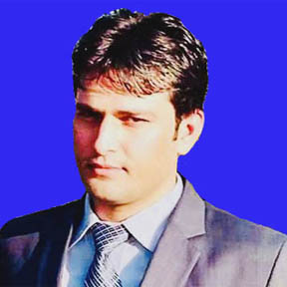



* **System Administrator** **(DIPLOMA)**
  + MCSE: (Microsoft Certified Sysestem Engineer)
* **Network Administrator** **(DIPLOMA)**
  + CCNA: (Cisco Certified Network Associate)
* **CCTV:** **(DIPLOMA)**

Closed Circute Television

* Six month experience in Nadra as **System Engineer.**
* One year teaching experience of **Capital Degree College in Peshawar.**
* Warks since Sep, 2018 to till date as Acccountant of Project Title **“Integrated of Livestock Merged Areas”**, in the office of Directorate of Livestock and Dairy Development Department Merged Area Secretariat, Warsak Road Peshawar.

Lahore 8th SEP, 2015

Zahid badshah Shalmani

**Qualifications**

* C++ (Created Semester Projects)
* My SQL (Created Semester Projects)
* JAVA (Created Semester Projects)
* VP (Visul Programming)
* C# (Created Semester Projects)
* Android Studio (Created Final Year Project)
* Distributted Database,

**References:**

* Will be furnished on request.

**Working Experience**

**Programming**

**Networking**

**Operating System**

**Application**

* DESIGN: (In page, Coral Drow, PhotoShop)
* OFFICE: (Microsoft OFFICE(P-Point, Word, Excel, Acces)
* Good Knowledge OF Internet Operations
* Other Software: ( Like Packet Tracer and much more ).
* Window as Administrated
* Microsoft All Windows installation
* Window Server 2012 R1and R2
* Window Server 2012 R1and R2