Curriculum Vitae
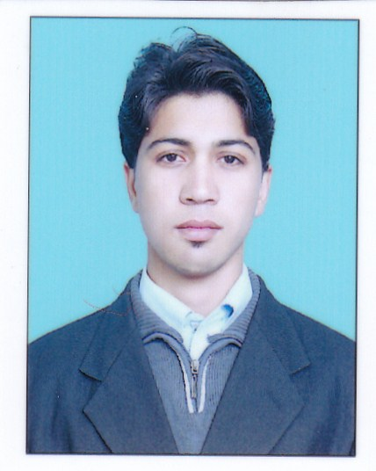
ZUBAIR GUL
Mohallah Mian Kali P.O Prang
Tehsil & District Charsadda
Cell#: 0313-9439616

OBJECTIVE:
- Seeking Challenging and responsible position, where my education, ability, potentials can be fully and effectively utilized with opportunities of growth, enhancement of knowledge and I am immediately available, dynamic, personable and experienced with strong communication skill.
PERSONAL
Father Name : Ikram Ullah
Date of Birth : 10-03-1996
Marital Status : Single
Nationality : Pakistani
CNIC No 17101-5175674-9
Religion : Islam
Domicile : Charsadda (Khyber Pakhtunkhwa)
ACADEMIC QUALIFICATION:

Degree | Year | Obt: Marks | Board / University
S.S.C | 2012 | 802/1050 | BISE Peshawar
F.Sc (Pre-Engg) | 2014 | 718/1100 | BISE Peshawar
B.Com | 2016 | 825/1400 | University of Peshawar
D.I.T | 2016 | 1144/1400 | BTE Peshawar

COURSE:
- Three months typing certificate from Frontier Institute of IT Charsadda.
EXPERIENCE:
- Working at Kaizen Pharma as Accountant and also as Operator.
- Work as a Medical Representative in STALLION Pharma (PVT) Ltd.
- Working at UDL Distribution PVT Ltd as a Accountant.
- Working at UDL Distribution PVT Ltd as as a Cashier
LANGUAGES

- English, Urdu, Pashto

