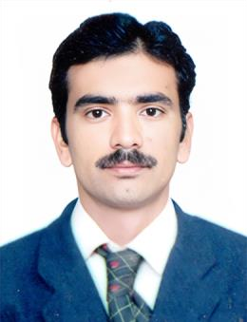

**WASEEM JAN**

**'**

**Objectives:**



My objective is to achieve excellence in a dynamic organization. I enjoyworking as a part of an effective team in a friendly environment. I am capable of working on my own initiative and possess organizing abilities. I possess good communication skills and capable to work under pressure to meet deadline. I always work hard and efficiently to achieve my goal.

# PERSONAL PROFILE

* Father’s Name : Ismail Khan
* Gender : Male
* Nationality : Pakistani
* Religion : Islam
* N.I.C : 17101-1662582-1
* Domicile : Charsadda
* D.O.B. : 25-02-2002
* Cell # : 0311–1928461 
* E-mail : waseemismail2019@gmail.com
* Postal Address : Muslim Abad Railway Station Mardan Road Tehsil & District Charsadda

# ACADEMIC QUALIFICATION

|  |  |  |  |  |  |
| --- | --- | --- | --- | --- | --- |
| **Exam** | ***Passing Year*** | **ObtainedMarks** | **Discipline** | **Percentage** | **Board*/*University** |
| ***BS***  ***COMMERCE*** | *2023* | *3.74 / 4.00* | *Accounting and Finance* | *76* | *GCMS/BKUC*  *(2019-2023)* |
| ***D.COM*** | *2019* | *780/ 1200* | *Accounting* | *65* | *KBTE Peshawar* |
| ***SSC*** | *2017* | *708/1100* | *Science* | *64* | *BISE Peshawar* |
| ***TYPING*** | *2022* | *30wpm* | *Typing* | *(97%)*  *Accuracy* | *FIT* |

# Experience

|  |  |  |  |
| --- | --- | --- | --- |
| **ORGANIZATION** | **DESIGNATION** | **FROM** | **TO** |
| **Postex (Call Courier Delivery Services )** | *Accountant* | *19 Jan 2024* | *10 Aug 2024* |
| **U Micro Finance Bank Ltd** | *Teller (Cashier)* | *03 Sep 2024* | *Till to Date* |

# Achievements

* Provincial Level Declamation Contest arrange by (NAB). 2nd Position in English Declamation.
* Anti-Corruption Annual Competition arrange by GCMS-II Peshawar. 1st Position in English Declamation

# Language

❖ English Urdu Pashto

# Software

Go Green

Pibas

SAP

Roseetta

TBS