**IMTIAZ ALI S/O SHER MUHAMMAD**

# 

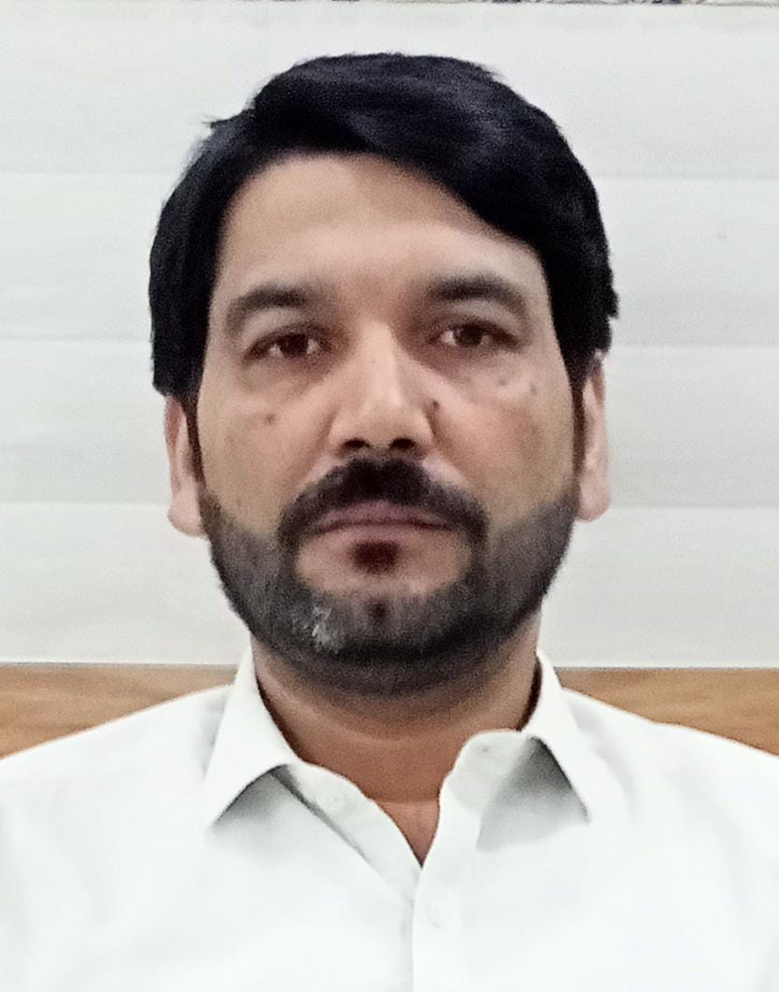

Address: P/O BAHLOLA TEHSIL AND DISTRICT CHARSADDA.

Cell: +92 333-9847532

Email: Imtiazalidob85@gmail.com

**OBJECTIVE:**

To serve in an organization using my knowledge, skills and abilities and contribute towards the strategic goals, viz a viz enhancing my skill set. To be part of a team with realistic and result oriented attitude with a view to effectively achieve the competitive advantages through dedicated efforts and teamwork.

**QUALIFICATION:**

* MBA from National University Of Modern Languages.(NUML)
* M.Sc. Economics from University of Peshawar.
* B.Sc Mathematics from University of Peshawar.

**Courses / Certificates**:

* Banking Complete training from Learning & Development HBL Islamabad
* Up Your Service training by Ron Kaufman of Singapore with certificate.
* Complete training on office safety and security issues with certificate.
* Complete training on Gender Diversity with certificate.
* Complete training on Anti Money Laundering (AML) with certificate.
* Best manager of the year 2016 award with certificate.
* Complete training of i-secure relating security, password management,phishing,cardskiming and ransom ware with certificate.
* Training on “understanding and handling harassment in the workplace” with certificate.
* Training on “Fair treatment to customers” with certificate.
* Internship certificate from National Bank Of Pakistan.
* Certificate for attending a seminar on “Effects of Terrorism on business environment.
* One month training of SAP, an ERP software for businesses.

**EXPERIENCE & JOB DESCRIPTION:**

* **Assistant Manager Accounts Payable (Finance Deptt.)**

**Qazi & Bothers Group of Companies**.

(Qazi Chemicals PVT LTD. + Qazi Grinding Mills PVT LTD. + Kifayat Enterprises)

(**11 April 2021 to 31/10/2023)**

**My Key responsibilities include:**

* Management of All Account Payable, **Treasury**, and dealing all operations of Deptt.
* Monthly basis Reconciliation of bank accounts with company’s accounts i.e. SAP.
* Ensuring High-quality Invoicing and collection/ Payment procedures that comply with local laws & Contractual Terms (Incl Credit Term).
* Maintaining and Managing Vendors and Customers Data Base.
* Preparation of Analysis of budgets and rolling forecasts for all factory related Functions.
* Independent analysis of full working capital cycle in the context of collection/Payments transactions.
* Planning, Managing & executing strategies to achieve target goals.
* Controlling and monitoring budget along with reporting on variances on monthly basis.
* Managing financial aspects of procurement to payment cycle from requisition to eventual conversion in to PO.
* Reporting on Financial performance and preparation for regular leadership reviews.
* Regular review of existing processes and highlighting control weaknesses, along with recommendation of mitigation of those risks.
* Organizing record of invoices, bills and deposits and ensure their availability at the time of requirement.
* Cross Functional liaison and team’s coordination on daily basis.
* Accomplishes organization’s mission by completing related results as and when required.
* Post Audit Rectification
* **Branch Manager at HBL:**

**HBL jalal branch district mardan.**

**08/08/2012 to 24/04/2020**

**My Key responsibilities included:**

* Overall supervision and management of day to day activities of bank.
* Expense and inventory management.
* Marketing/sales of HBL products.
* Customers and vendors dealing.
* Safety and security management of Bank/branch.
* Lease agreement settlements.
* Post audit rectification.
* **2.5 Years experience as coordinator in Quaid e Azam Public School Mardan Campus**

(07 April 2010 to 31 July 2012)

Key Tasks.

* Financial and academic coordination.
* School fee collection and staff salaries disbursement management.

|  |
| --- |
| **Competencies** |
| * + Excellent Problem Solving Skills   + Better Time management.   + Good Communication skills.   + Innovative, dynamic and confident.   + I believe in team work.   + I am self-assured and have excellent presentation ability. I enjoy speaking in public. |

**Softwares Handled:**

* SAP-B1
* MYSIS
* T24

|  |
| --- |
| **Languages** |
| |  |  |  | | --- | --- | --- | | **Urdu**(speak,write,read) | **English**(Speak ,write, read ) | **Pashto** (Speak,write,read) | |