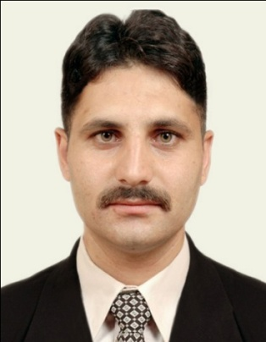

Alam zaib
Peshawar City , Pakistan .
Cell No. 0092-3149009687
Email: zaibadv2005@yahoo.com

OBJECTIVES:
A professional lawyer, keen to find a challenging position in a dynamic and growing Organization where I can utilize my knowledge and skills and capabilities which I gained in the whole academic career, and to serve in a challenging work environment and equally vast opportunities of career development based upon achievements and results.

Personal Information

Father’s Name : Shah Jehan
Father’s Profession : Government Servant (Retd)
Date of Birth : 29/08/1982
Religion : Islam
Nationality : Pakistani
Marital Status : Married
Domicile : Peshawar (Khyber Pakhtoonkhwa)
CNIC # : 17301-1239327-1

Academic Qualification

L.L.B University of Peshawar 2004
B.A University of Peshawar 2000
F.A Board of Intermediate & Secondary Education, Peshawar 1998
S.S.C Board of Intermediate & Secondary Education, Peshawar 1996

Professional Specialty

Criminal Law
Civil Law
Family Law
Constitutional Law
Rent Laws
NADRA Laws
Jerga Laws (FCR)

Professional skill/certificates
Good command over Microsoft Office Professional (MS Word, MS Excel, MS Access,
MS Power Point) Internet etc
Languages
- English
- Urdu
- Pashto

EXPERIANCES
1:- Practicing Lawyer at Distt. & Session courts Peshawar KPK, since Sep 2005
2:- Worked as Legal officer with INTERNATIONAL RESCUE COMMITTEE (IRC)
Since 3 oct. 2011 to 09 Nov.2014
3:- Worked as a Litigation officer (BPS 17) with/in Ministry of Mines & Mineral DGMM, H/Q KPK Peshawar
Since 10 Nov. 2014 to 30 june.2018

References will be provided on demand.

