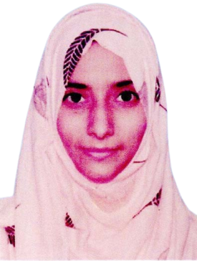Umulwara

**Address: House No. A/102, Mohallah Mir Nabi Bux Town**

**Paratabad District Hyderabad**

**Contact No: 0317-0037165**

**CAREER OBJECTIVE**

**Curriculum Vitae**

* *Innovative and attention to details define my thought process. Skilled at learning new concepts quickly, working well under pressure, and communicating ideas clearly and effectively. Provide consultation and solutions for successful delivery of the project from start till end.*

**PERSONAL INFORMATION**

* *Father’s Name Fareed Ahmed Shah*
* *Surname Syed Shah*
* *Date of Birth 23-04-2001*
* *CNIC No. 41302-4784921-0*
* *Religion Islam*
* *Marital Status Single*
* *Nationality Pakistani*

**ACADEMIC QUALIFICATION**

* ***Matriculation*** *from B.I.S.E Hyderabad.*
* ***Intermediate*** *from B.I.S.E Hyderabad.*
* ***B.A*** *from University of Sindh Jamshoro.*

**EXPERIENCE**

* *01 year experience as a* ***Teacher*** *in* ***Pak Public High School*** *Hyderabad.*
* *01 year experience as a* ***Data Entry Operator*** *in* ***State Life*** *Hyderabad.*

**PROFESSIONAL SKILLS**

* *18 months* ***English Language Course*** *from Student Care Centre Hyderabad.*
* *6 Months* ***C.I.T Course*** *from Student Care Centre Hyderabad.*

**LANGUAGES**

* *English*
* *Urdu*