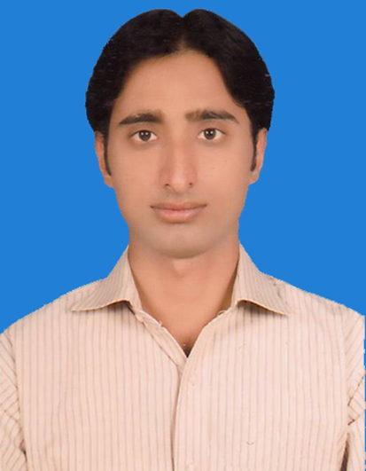
UMER LODHI

- 0308-6387779
  - umerlodhi1984@gmail.com

OBJECTIVE

A challenging career in a value oriented organization to maximize my potential, growth and performance.

.

ACADEMICS

Bahauddin Zakariya University, Multan.
(2010) Graduation

Board of Intermediate & Secondary Education, Multan.
(2000-02) ICS (Inter with Computer Science).
Board of Intermediate & Secondary Education, Multan.
(1998-00) Matriculation Science

COMPUTER SKILLS

Microsoft Office.
Internet & E-mail.
Writing & Communication Skills.
Website search engine.
Can Maintain Hardware & Software

EXPERIENCE

- Currently working as Area Sales Manager in Haji Bashir & Sons (The Cement Services) since January 2013.
- 02½ Years worked as Sales Officer in MAPLE LEAF CEMENT from June 2010 to Dec. 2012.

PERSONAL

Father’s Name Abdul Rehman Khan Lodhi
Date of Birth 09-03-1984
Marital Status Married
Domicile: Multan (Punjab)
C.N.I.C. # 36302-9660255-9

