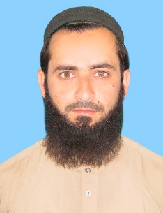

**Sohail Kamal**

Email: sohailkamal22@gmail.com

Mobile: +92-342-5115215

Whatsapp +92-3419606460

***Objective*** 🡺

Seeking for a challenging post where excellent working conditions

Conductive to character building and development of managerial skills

Are provided.

## **PERSONAL INFORMATION:**

Father’s Name : Said Kamal

Gender : Male

Domicile : Swabi (KPK)

Date of Birth : 20-05-1991

Religion : Islam

CNIC No : 16202-2133856-5

Marital Status : Single

Postal Address : Moh Mohib Banda, Vill & P.O

Dagai Tehsil Razzar, District Swabi.

## **Qualification**

|  |  |  |  |
| --- | --- | --- | --- |
| **Academic** | **Session** | **Marks** | **Board/ University** |
| SSC (Science) | 2009 | 535/1050 | BISE Mardan |
| F.Sc (Computer Science) | 2011 | 585/1100 | BISE Mardan |
| B.Sc (Computer Science) | 2013 | 280/550 | AWKU Mardan |
| Master in Sociology | 2016 | 1527/2100 | University of Swabi |
| D.I.T | 2013 | 1024/1400 | BTE Peshawar |

## **Experience:**

* 7 years working experience as Data Entry Operator, Registration & Verification Officer, & Food Distributor, Food Assistant Officer with CERD Organization (WFP) at Bannu from 2013 to September 2020.
* Only one year experience in AWAZ II project in I’m the post of Field reporting officer January 2021 to December 2021
* Cash officer in Cakes&Bake in February 2022 to tell date

## **Courses/ Skills**

* Good Command over Ms word ,Ms Excel &Ms power point
* Typing Speed 40 to 45 WPM
* Full command on Internet Surfing & Searching

## **Languages:**

* English, Urdu & Pashto