MINHAJ UDDIN
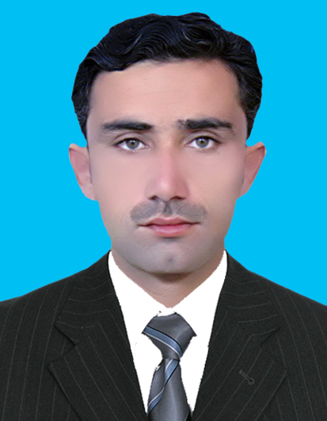
Address: Village: Zoor kandi shabqadar P/O: Shabqadar,
CURRICULUM VITAE
Tehsil: Shabqadar, District: Charsadda.
Cell: 0333-9262687
Email Address: minhajuddin764@gmail.com

Job Objective

Seeking challenging and responsible position where my education, ability, potentials can be fully and effectively utilized with opportunities of growth, enhancement of knowledge and to serve in building the nation.

Personal Information

      - Father Name Zaheer Uddin
      - Date of birth 09/03/1988
      - Religion Islam
      - Nationality Pakistani
      - Domicile Charsadda
      - Marital Status Married
      - NIC No: 17101-1886417-9

Education

Degree/Certificate | Obtained /Total Marks | Grade | Year | Board / University
S.S.C (Science) | 474/850 | B | 2004 | B.I.S.E Peshawar
D.Com | 769/1200 | B | 2006 | KPBTE Peshawar
IT | 104/150 | A | 2006 | KPBTE Peshawar
B. Com | 669/1400 | B | 2010 | University of Peshawar
MBA | 2.56/4.00 | B | 2011 | AWKUM Mardan

Languages

- ENGLISH
Good in written & verbal proficiency with fluent/full working knowledge.
- URDU
Excellent in written & verbal proficiency with fluent/full working knowledge.
- PUSHTO
- Arabic in writing $ verable with full wprking knowledge
Excellent in speaking & written with fluent/full working knowledge.

=

EXPERIENCE:

* Working as a TTM with W.H.O.
* Worked as in assistant casher in PIMS (Hospital)
* Worked as supervisor with EPI.
* Two years’ experience Private Teaching.
* LTV driver
* Computer skill M.s Word, Excel.

=

Hobbies

- Reciting Holly QURAN.
- Reading Books (Historic, Islamic & Poetry), Newspaper and Novels.
- Games (Cricket).
- Internet Uses (Chatting).
- Physical Exercises.

