  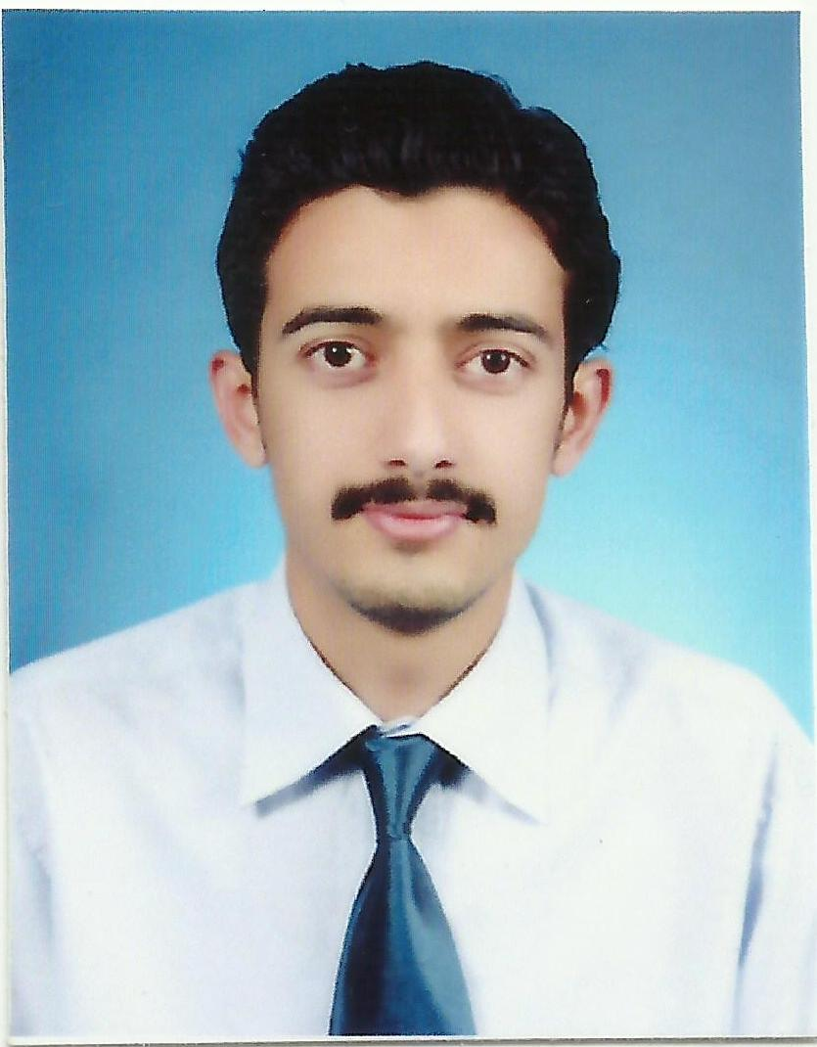 Azwar Mazhar Butt
  Citizenship : Pakistani ▪ Date of birth : 11 October 1988
  CNIC # :17301-0920200-5 Passport # : AQ3492002
  Contact
  Tel : +92 313-5925221
  Tel : +92 335-1504459
  e-mail : azwarbutt@gmail.com
Address
Butt Market, Mohallah Hidayatullah Shah, G.T. Road, Peshawar

Profile
Objective | Willing to enhance horizons of knowledge and experience in my field; energetic and creative; able to work alone yet flexible enough to work as a team member or leader.

Key Skills
- Hard working & devoted to tasks

- Team player with excellent interpersonal skills

- Knowledge & use of technology

- Strong analytical & problem solving skills

- Excellent written and verbal communication skills in English.

Other skills
Microsoft office (word, power point, excel)

Education
2007 to 2011 | B.S. (Electronics Engineering)  COMSATS Institute of Information Technology, Abbottabad
2004 to 2006 | F.Sc. (Pre-Engineering)  Peshawar Model Degree College, Peshawar
2004 | Matriculation  Peshawar Model School, Peshawar

Major Courses
Electronics, Microwave, Principal of communication, Digital signal processing, Data communication and industrial electronics.

Certificates
Solar panels installation certificate from National institute of design and analysis (nida).
PLC and SCADA certificate from National institute of design and analysis (nida).
Post Graduate Diploma in (GIS) from NCEG Peshawar university. (2018-2019)
Work Experience
Nokia-Siemens Networks | Internship 2010
- Familiarized myself with the design of Juniper routers
- Learned about the architecture and components of GSM networks
- Learned about upcoming technologies such as 3G and LTE
Telecommunication services networks (TSN) | TE Field Engineer
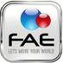F&A Enterprise Pvt. Ltd January 2013 to December 2014
Working as a transmission engineer in the firm, a subcontractor of Huawei.

Job Responsibilitie
- BTS 3900,DBS 3900 Apm30, HPS 48300, HPS48200, RTN 605,610,620,905,910,950.
- Installation, configuration, link, media clearance from BSC, Ring, Offane, lease line (PTCL) to site.
- Media ,link on RTN 905, 910,950,980&Nec.
- Traffic Shifting.
- RTN Up gradation
- HPMU Up gradation
- Alarms verification and troubleshooting.
FORT Pvt limited February 2015 to August 2015

- Electrical Supervisor.
MUSLIM Cambridge school
Biology and chemistry teacher November 2015 to February 2017

Company: Sun save Pak.
Solar systems installation. July 2020 to dec 2021
Company: Solar First Enterprises
Manager may 2021 to upto date

Final year Project
AM station design for the campus.(using amplitude modulation)

Languages
Urdu, English, Pashto, Punjabi and Hindko

References
Available on demand

