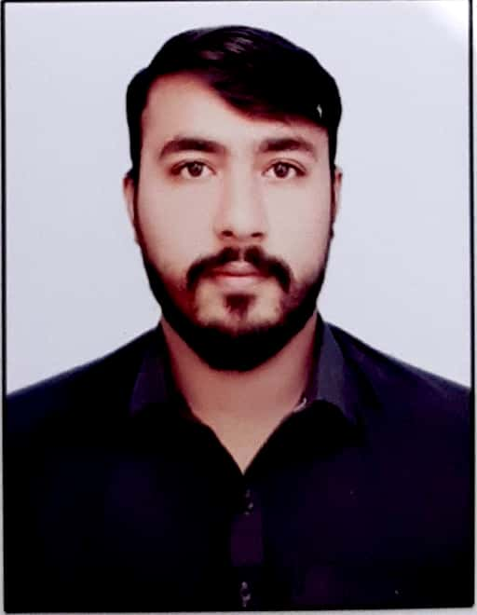

**EXPERIENCE**

✓ **Cashier (Jan 2024 – Continue)**

Saddiq Exchange Company (Peshawar Deans Branch)

* Processing remittance transactions, including sending and receiving money worldwide (MoneyGram, Western Union, Ria)
* Handling foreign currency transactions, including buying and selling currencies using FMS (Financial Management System)
* Complying with anti-money laundering (AML) and know-your-customer (KYC) regulations
* Maintaining accuracy and efficiency in handling cash and electronic transactions by Posting Entries in FMS
* Counting and balancing cash, and preparing daily reports on XLS
* Developing strong communication and problem-solving skills in a fast-paced environment
* Staying up-to-date with exchange rates, market trends, and regulatory requirements

✓ **Manager (Feb 2023 – Dec 2023)**

ShellAzakhel Filling Station (Nowshera)

* Posting of general entries (self-oriented XLS)
* Billing / Invoicing
* Stock Taking
* Cash Handling (Receipt / Payment)
* Payroll Incharge
* Staff Meetings
* Handling Company Safety Audits
* Maintaining Manager Diary (Daily Bases)
* Decantation
* Financial Reporting
* Monthly Closing of all the Accounts (Self Oriented XLS)

✓ **Cashier cum Assistant Manager (Jan 2021 – Dec 2022)**

M/s Shell Yakatoot Filling Station (PEW)

* + - Cash Handling (Receipt / Payment)
    - Stock Taking (Inventory)
    - Billing / Invoicing
    - Supervise and Control all Employees at Filling Station
    - Preparing Bank Draft for bulk payments
    - Supervise payroll
    - Posting of general entries (self-oriented XLS)

**EDUCATION**

✓ **BBA (Hons) (2024)**

Govt. College of Management Sciences Peshawar

Affiliated with Peshawar University

✓ **D.Com (2019)**

Govt. College of Management Sciences Peshawar

✓ **SSC (Matric – Science) (2015)**

Creative Learning School Gulbahar, Peshawar

**BIO DATA**

✓ **F_Name** Syed Noor Ali Shah

✓ **CNIC** 17301-7126561-5

✓ **Religion** Islam

✓ **D.O. Birth** 25 Nov 1999

**HOBBIES**

READING

WRITING

TRAVELING

MUSIC

SPORTS

**PROFILE**

To follow, emerge & accomplish position in an organization which ideals its goal lines and commitment to achieve its business trade. To enhance my career with implementing my skills and abilities to perform and realize goals for my personal profession and position.

📧 syedsaqlainhaider002@gmail.com

📞 0331-8819849

🏠 Dalazak Road Yousaf Abad Peshawar

**LANGUAGES**

URDU

ENGLISH

PUSHTO

HINDKO

**SKILLS**

MS Office Suite

Drafting

Financial Reporting

***SYED SAQLAIN HAIDER***