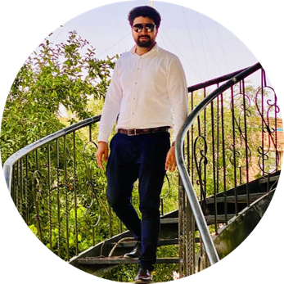  Sameer Anwar Marketer  Contact  Address  Gulabad no 1 Peshawar sadder  Phone  03138988803  E-mail  sameerkhanqureshi001@gmail.com  Skills  - Marketer( Sales, Marketing, Negotiations)  - communicator  - Supply chain  (Procurement)  - Digital Marketing  - Canva Expert  - Social Media Management  - E-commerce Expert  - Excellent Communication Skills  - MS Office  - Content Writer  - Presenter  - Fluent English communicator | Enthusiastic, eager to contribute to team success through hard work, attention to detail and excellent organizational skills. Clear understanding of task, Motivated to learn, grow and excel in organization.  Work History  2022-02 2024-02 Communication officer (On the Behalf of Dealer) Atlas Honda Limited , Peshawar Working in the domain of Procurements and Financial institute Responsibilities: I am a communication officer between my company and the the government institutes plus between the financial institutes (Banks). I coordinate between my company and different government and financial institutes. I worked in the domain of procurements of government institutes and the leasing domain of banks. My responsibility is to coordinate all the information between the Government institutes about the procurements plus the leasing domain of banks with my company. Making reports daily about the updates and plan how should we have to communicate with the department in future.  Education  2013-06- 2015-06 Matriculation: Science Peshawar Public School And College Peshawar `  2015-07 - 2017-07 F.Sc : Pre-Engineering F.G Degree College Peshawar - Peshawar Cantt  2017-07 - 2022-04 BBA (Hons): Marketing Sarhad university of information and technology Peshawar  2022-09-  2024-02 MBA (Marketing)  Institute of Management Sciences Peshawar
.

