0

01/02/13 to

29/11/15

Dawn Bread

++Faisalabad

**Assistant Sales Manager**

Achieve sales goals, , Analyze sales data,identify trends, Team Collaboration. Training junior sales team. strong relationships with clients.

**EXPERIENCE**

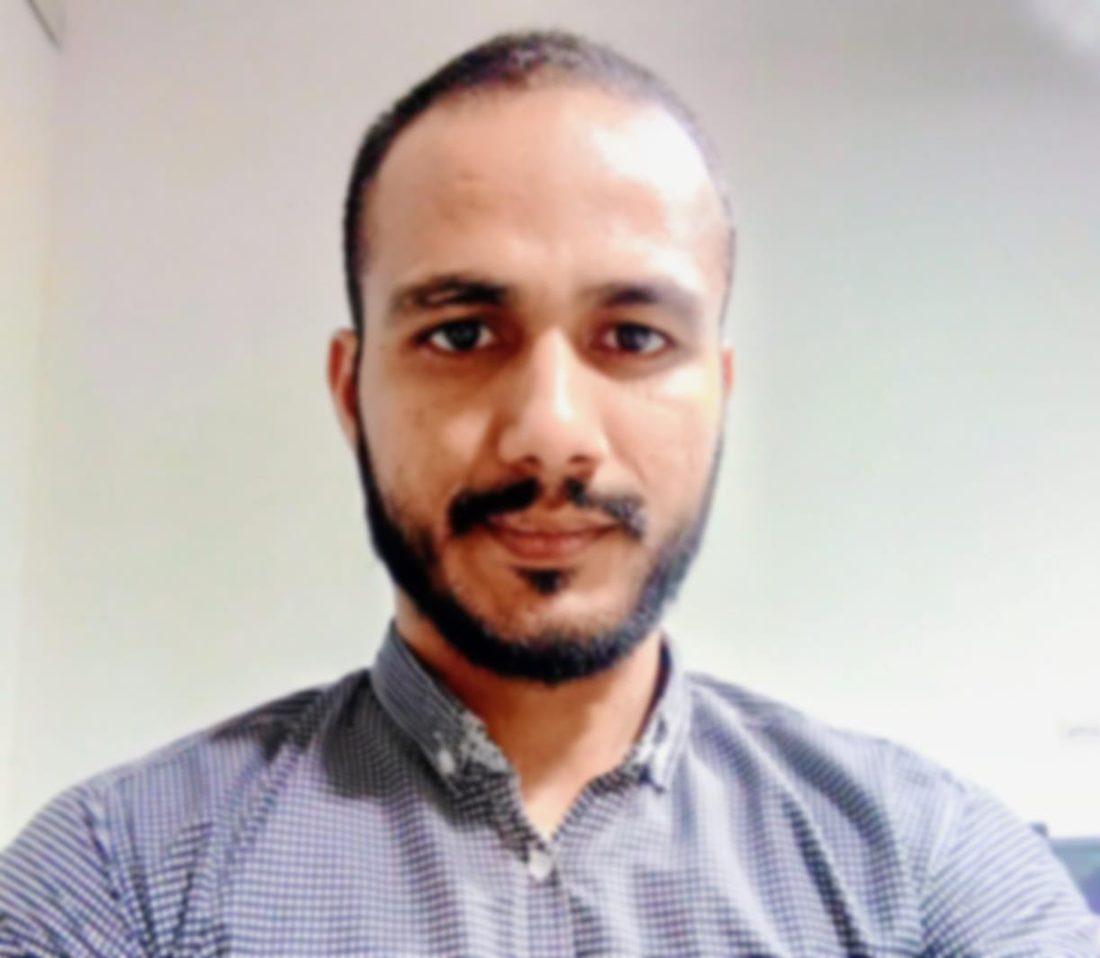



**Sales Manager**

**Area Sales Manager**



**CNIC: 33102-5284732-1**

**DATE OF BIRTH: 17-10-1992**

**ADEESS: Ahmada bad street-1**

**House number 554 faislabad**

**MARITAL STATUS : single**

Address: Armada Abad st.1 Gulistan colon Faisalabad

2nd Division

B.I.S.E Faisalabad

2007-2008

**Matriculation**

2st Division

B.I.S.E Faisalabad

2008-2010

**I.COM**

2nd Division

University of Punjab Lahore

**B.COM**

2011-2013

2.64 CGPA

University of Agriculture Faisalabad

**MBA Executive Marketing**

2018-2020

**EDUCATION**

05/12/15 to

28/8/18

Hamd food & Co Faisalabad

**Area Sales Manager(FMCG)**

Team management, Problem solving,

Customer feedback, increase sales Strategies and profit goals, report analysis, coordinate with ZSM, Develop PR, and Target Setting

Stock Maintain

**Imtiaz Hussain Shah**

01/09/18 to

26/12/23

Inter Loop Limited Co. Faisalabad

**Assistant Sales Manager**

Customer Dealing, Price negotiate with Customer, Risk Assessment Meeting

Customer Satisfaction, FIFO Implement, Team management,

Sales and marketing with 11 years of extensive experience in product and process Sales. Profitability and Customer Ranking Reports with Opportunity Profit & Loss. Also well versed in drafting E-Mails and doing correspondence with the stake holders and Customer. Having good hand on MS Excel, Word, PowerPoint, ERP (Oracle) and also attended training sessions of Product Development Customer focus

**SKILLS**

MS EXCEL

MS WORD

S

MS POWERPOINT

**Languages:**

English Fluent

Urdu Native/Bilingual

Punjabi Native/Bilingual

ERP (ORACLE)

Communication

**Email: imtiazshahgillani@gmail.com**

**PHONE: 0312-4444125**

**CONTACT**