URRICULUM ITAE

SALEEM KHAN

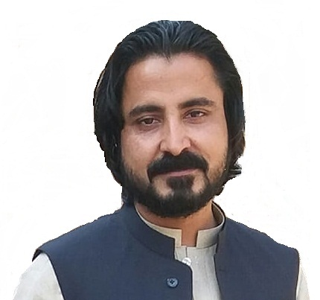
P.Address: Village Achini Payan, Mohalla Daraz Abad, Distt.
& Teh. Peshawar, P/O University of Peshawar Pakistan.
T.Address: Madina Town Gadwal Wah Cantt.
Email Address: khan005.khani007@gmail.com
Cell No + Whtsap# +92 311 7788321 & +92 343 0003304

Objective

To be a responsible team member of your organization and to work hard so as
to carry out the assigned tasks using my professional capabilities and skills.

Personal Profile
Father’s Name : Hastam Khan
Domicile : Peshawar Pakistan
Date of Birth : 18-April -1984
Nationality : Pakistani
CNIC No. : 17301-7007017-9
Pass Port# : GT4110172
Gender : Male
Marital Status : Married

Academic Qualification

MBA (2009) Peshawar Business School, University of Peshawar.
Major Subject
- Finance

B.Sc (2006) PAF Fazaia Degree College Peshawar, University of Peshawar.
Major Subjects
- Computer Science
- Statistics

F.Sc (2004) PAF Shaheen College Peshawar, Federal Board Islamabad.
Major Subject
- Computer Science

S.S.C (2002) PAF Shaheen School & College Peshawar, Federal Board Islamabad.
Major Subject
- Computer Science

Language Proficiency

- Pashto (native) , Urdu , English & Chinese.

Professional Qualification

- Office Ms. Word, Power Point, Inpage (Urdu and Arabic).
- Accounts Ms. Excel, Quick Book.
- Typing Speed English 40 words/min, Urdu & Arabic Enough.

Certification

- Hardware’s & Software’s Installation.
- C++ Language.

Computer Skills

- Excellent command on Operating System, Ms-Office, Hardware & Software and its installation, Complete command on printing & Internet.
Job Experience


- Worked as Accountant at Dost Welfare Foundation (KPK) Pakistan.

(From April, 2009 to Sep, 2009)
- Worked as Passenger Service Assistant at Pakistan International Airlines (KPK) Pakistan.
(From 21st Oct, 2009 to 1st Jan, 2010)
- Worked as Computer Operator at Dost Welfare Foundation (KPK) Pakistan.
(From 1st Jan, 2010 to 30th, April 2010)

- Worked as Computer Operator at Frontier Science Academy (KPK) Pakistan.

(From 23rd Aug, 2010 to 20th May, 2013)
- Worked as Sales Representative at Alma Trade Building Material (Al-Qouz) Dubai.
(From 22nd May, 2013 to 22nd Aug, 2013)
- Worked as Computer Operator at Frontier Science Academy (KPK) Pakistan.
(From 1st Sept, 2013 to 13th Jan, 2016)
- Worked as Sales Executive at Heaven Marketing Pvt. (Ltd.) (KPK) Pakistan.


(From 15th Aug, 2016 to 15th Dec, 2017)
- Worked in I.T Section (Contract) at Orthopedic KTH (KPK) Pakistan.
(From 11th Jan, 2018 to 30th April 2019)
- Worked as Accountant at Kababish Restaurant G-15 & New City (Islamabad) Pakistan.

(From 1st June, 2019 to 31st Dec, 2019)
- Worked as Manager Accounts at Shangrila Resort & Hotels Skardu Baltistan, Pakistan.
(From 20th Jan, 2020 to 20th September 2021)
- Working as Accountant at Naran Creek Hotel bypass road Naran, KPK, Pakistan.
(From 21st September, 2021 till Date)

References

- References will be provided on demand.

