**Objective**

**SAAD UL ISLAM**

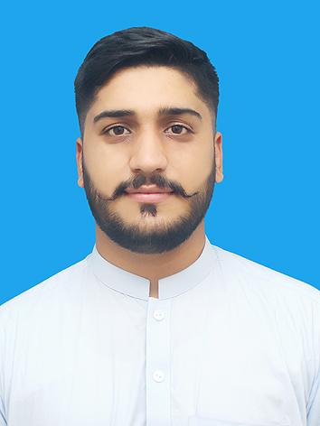

**S/O:** MUHAMMAD ISLAM

**DOB:** 27 NOV, 1996

**CNIC No.:** 16202-7193351-7

**Nationality:** Pakistani

**Address:** Mohallah Taus Khel, village Maneri Payan Distt and Teh Swabi, KPK Pakistan.  
Zip code: 23430  
City: Swabi

Cell Phone: 0336-9768006, 0332-9400699

Email: saadulislam.ties@gmail.com

To secure a position in an organization that would fully employ my personal skills, my experience as well as my academic training in a rewarding career that affords professional and personal growth.

**Education**

1. **MPhil (Master’s in Software Engineering)**

**Institute:** University of Swabi

**Session:** 2020 to 2022 (Continue)

1. **BCS Hons (Bachelor of Computer Science)**

**Institute:** University of Swabi

**Session:** 2015 to 2019

1. **HSSC (Higher Secondary School Certificate)**

**Institute:** Tameer-e-Seerat schools and colleges system Swabi

**Session:** 2014 to 2015

1. **SSC (Secondary School Certificate)**

**Institute:** Tameer-e-Seerat schools and colleges system Swabi

**Session:** 2012 to 2013

**CERTIFICATions**

* 1st Workshop on Computer Based Software Application in Research
* Cyber security Attack and Defensive Measures
* 2nd Workshop on Computer Based Software Application in Research
* Office Automation
* Training certificate on Mobile App Development by Codematics Inc
* 1st International Conference on Software Engineering and Computing Disciplines
* Training Certificate on IOS/Android App Development using Flutter by Cybervision International.
* Internship Completion Certificate in Mobile App Development under KP Digital Internship Program.

**sKILLS AND Experties**

* Programming with C, C++, Java and Dart.
* Android App Development using Java.
* Mobile App Development using Flutter (cross platform).
* Database development.
* REST APIs
* App Frontend Designing.

**experience**

* Three years of experience in Mobile Apps Development
* 2 months training on Mob Apps Development in Codematics Inc.
* IT Instructor in Swabi College of Information Technology Swabi (part time).
* 1 year Experience in Mob App Development (Flutter) in Khyber Pakhtunkhwa Information Technology Board Peshawar.
* Project Associate working as Mobile App Developer (Flutter) in Industries Commerce and Technical Education Civil Secretariate KP.

**personal strength**

* I am an adaptable person.
* I can acquire new skills quickly.
* I have good English communication skills.
* I have a special interest in Development, Designing, IT, and Research Area.

**Projects**

* Research Paper published in 1st International Conference on Software Engineering and Computing Disciplines 2019.
* Incoming Call Blocker Android Mobile Application.
* Chat Application.
* Authentic Quran App for KPITB (verified by Ministry of Religious Affairs, Govt of Pakistan)
* Worked on KP Centralized Collaboration App for KPITB.
* Consumer Complaints System for Industries Department.
* Power Crusher and Firms registration Application for Industries deptt

**Live Applications Links**

* Authentic Qur’an

<https://play.google.com/store/apps/details?id=com.authentic.quran>

**Language proficiency**

* Pashto (First Language)
* Urdu
* English