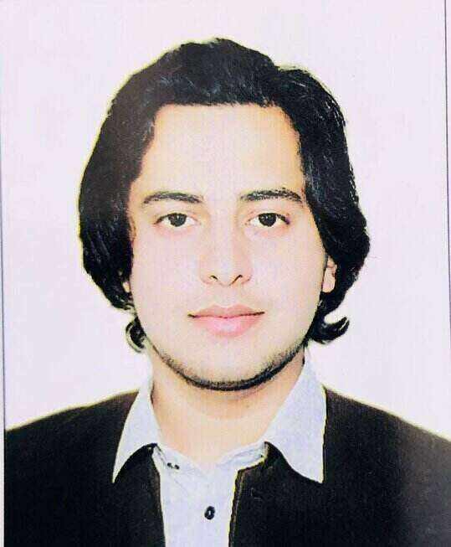

🡺Objectives

**Enterprising manager successful in leading every facet of a new and ongoing business operation. Strategic thinker and tactical decision maker with passion for serving customers and exceeding expectations. Creative problem solver skilled at de-escalating situations and driving positive change.**

🡺Work History

***★*Branch Manager: *[1st Aug 2022-31st june 23]***

**MR COD UK’s traditional fish n chips Peshawar**

* **Strengthened communication skills through regular interactions with others.**
* **Delivered services to customer locations within specific timeframes.**
* **Demonstrated creativity and resourcefulness through the development of innovative solutions.**
* **Applied effective time management techniques to meet tight deadlines.**

***★*Branch Manager*: [Feb2022-Aug2022]***

**Downtown Bistro Peshawar**

* **Branch Operations Management.**
* **Team Development.**
* **Organizational Development.**
* **Process Redesign & Improvement.**
* **Regulatory Compliance.**
* **Employee Morale & Retention.**

***★*Floor manager: *[Aug2020-Aug2021]***

**Downtown bistro Peshawar**

* **Made personal recommendations for customers by sharing product knowledge and demonstrating product.**
* **Offered hands-on assistance to customers, assessing needs, and maintaining current knowledge of consumer preferences.**
* **Oversaw supply restocking, area cleaning and product organization.**

**Muhammad**

**Zeeshan Khan**

**Father Name:**

**Abdul Ghani**

**CNIC:**

**15104-0351810-9**

**Domicile:**

**Buner (kpk)**

**Nationality:**

**Pakistani**

**Martial status:**

**Married**

**Address:**

**House-1, Street-8, sector j2, phase 2 Hayatabad.**

**Phone:**

**+92-345-4395442**

**Email:**

**mzeeshan38222@gmail.com**

***Skills:***

* ***Communication***
* ***Management***
* ***Marketing***
* ***Leadership***
* ***Project management***
* ***MS office***
* ***E-commerce***

***★*Cashier & all-rounder*: [Nov 2018-Aug 2020]***

**MR COD UK’s traditional fish n chips Peshawar**

* **Strengthened communication skills through regular interactions with others.**
* **Delivered services to customer locations within specific timeframes.**
* **Demonstrated creativity and resourcefulness through the development of innovative solutions.**
* **Applied effective time management techniques to meet tight deadlines**

***★*Cashier and filler*: [Nov 2017-Nov2018]***

**Shah CNG Station Peshawar**

* **Friendly and positive attitude.**
* **Excellent customer service.**
* **Excellent communication skills.**
* **Ability to make change.**

🡺Education

* ***SSC (Government Huzaifa aftab Shaheed higher secondary school Hayatabad) 833/1100 2023 BISEP.***
* ***HSSC (Government Huzaifa aftab Shaheed higher secondary school Hayatabad) 758/1100 2023 BISEP.***
* ***BBA (University of agricultural Peshawar)***

***5th semester in progress with 3.42 GPA.***

* ***DIT (Board of technical education Peshawar)***

***1039/1400 2023 BTE.***

***Workshops:***

***🡺STEP Peshawar. (2 Days).***

***🡺Red Crescent Foundation (basic first aid training 2 days).***

***🡺Polio volunteer (2 days).***

***🡺 Boy scouts (3 years).***

***Hobbies:***

* ***Modeling.***
* ***Fashion designer.***
* ***Beauty advisor.***