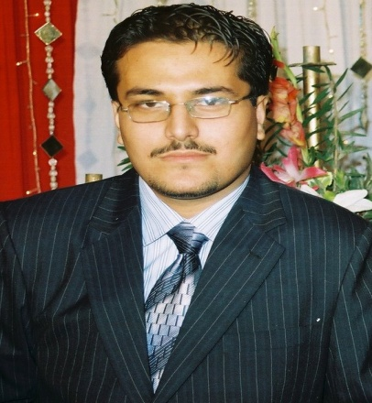

**Adil Zaki**

**Mobile No: +092332-9934230**

**Email: Adilzakis7860@gmail.com**

**PROFESSIONAL SUMMARY**

A Highly motivated and results driven finance specialized who has about 4 has about 4 years of invaluable experience in leading and developing a successful finance team. Skilled in numerous financial and accounting fields, monitoring secrecy and examinations of different education sector. Having the ability to handle complex assignments effectively & possessing the confidence to work as part of team or independently. I am presently looking for a suitable opportunity position with a forward thinking company where I can excel, deliver & achieve my potential.

**PROFESSIONAL Experience**

**APSACS School and colleges System From 2019 to present**

**Mainly responsible for,**

Teaching of English Language and Literature to class 7 to 12 and has given good results in board for their students and also deliver top 10 position Apsacs LandiKotal

In charge of Unity batch from 2 years

Member of literature group from 2 years

Total 7 years of experience of teaching

**NCS College System and University From 2019 -2022**

**Mainly responsible for,**

Teaching of English Language and Literature to class 9 to 12 and has given good results in board for their students and also delivers IELTS lectures to their students

**Invigilator/Supervisor 2016 (Present)**

**NTS: Mainly responsible for,**

* Setting up and running of examinations.
* Preparation of examination hall/room exam board standard
* Supervision on the invigilators and inspections of the Examination Hall

**Examination Officer Jan 2013 to Oct 2019**

**SARHAD UNIVESITY**

**Mainly responsible for,**

* Communication with examinations boards for registration entries.
* Liasing with Heads of Centers/Subject Teachers on deadlines and examination time tables.
* Distribution of exam board correspondence to subject Teachers/Heads of Centres.
* Safe keeping of examination papers and other confidential exam board information
* Setting up and running of examinations.
* Booking of facilities for examinations.
* Preparation of examination hall/room to exam board standard
* Invigilation Schedule
* Posting results to Heads of centre/subject Teachers.
* Reporting equivalencies information for examinations taken.
* Providing data to executive Head teacher for analysis
* Preparation of Verification letters for the students regarding Normal Verification, HEC letters, Embassy Letters and Qatar Embassy Letters with respect to their Transcript/ Degrees/Diplomas/Certificates.

**Secrecy CO-ORDINATOR**

**Jan 2013-Oct 2013**

**QURTUBA UNIVERSITY**

**Mainly responsible for,**

* Developing implementing and administrating all aspect of the secrecy.
* Monitoring the area of secrecy.
* Co-ordinate the student information system for Main the Campus and across University.
* Ensure compliance with student records.
* Store and preserve academic records and inactive student folders.
* Preparation, Publishing and storing of Exam papers.
* Checking the Validation of degrees/transcript/Diplomas/Certificates.

**Operational Manager**

**Jan 2012-Dec 2013**

**DEXTERITY Logistics Procurement**

* Recommend optimal transportations modes, routes and equipment.
* Establish and monitor Supply
* Plan and implement material flow management systems.
* Dealing with shipping and export processes.
* Negotiate with supplier’s rates and services.
* Develop risk management program to ensure continuity in supply.
* Analyze the financial impact of logistics changes.
* Communication with freight transportation

**RELATIONSSHIP OFFICER**

**Jan 2011-April 2012**

**NEW JUBILEE LIFE INSURANCE**

* To ensure that market intelligence is carried out in order to identify prospects and establish their needs.
* To ensure proper dissemination of products knowledge to the intermediaries/direct customers.
* To give competitive quotations and ensure follow ups are done for the same.
* To facilitate timely issuance of relevant documents.
* To discuss the upcoming relevant to avoid and ensure business retention.
* To advice customers/clients on claims procedures i.e timely reporting and relevant documentation.
* Organizing agents seminars
* Carrying out risk surveys

**INTERNSHIP**

**Oct 2011-Dec-2011**

**MULTI SUPPORT ENGINEERING AND CONSULTANCY SERVICES**

* Assistant the Financial Analysts with financial reporting and analysis.
* Ad-hoc reporting.
* Data entry and analysis
* Office filling.
* Other office tasking as assigned.

**TEACHING EXPERIENCE**

* I have taught all subjects except maths & Statistics in Fawad Model |School for 2 years.
* I have also taught for about 1 year in Govt Primary School Badaber No.1 Peshawar.

**ACADEMIC QUALIFICATION**

* Passed SSC Examination from Federal Board in 2006
* Passed HSSC Examination from Peshawar Board in 2008
* Passed BBA (hons)Examination from Gandahara University Peshawar in 2013
* Passed MS Finance from Bacha |Khan University Charsadda in 2016
* Passed MA Education from Sarhad University in 2018