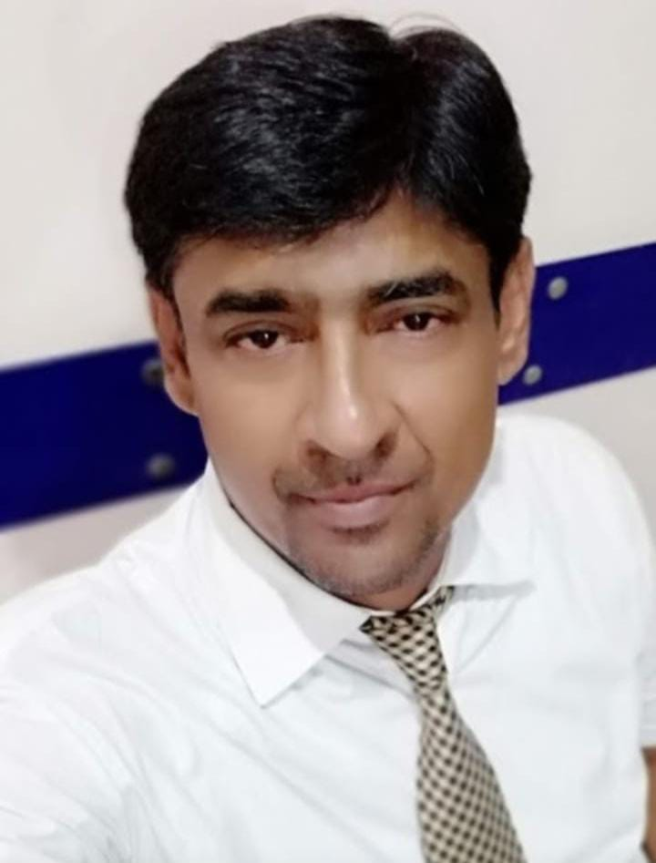
MUHAMMAD ALI ARAIN
Present Address
FLAT # A34 Block-A 4th Floor Sidique Plaza Latifabad
Unit No.08 Hyderabad. Sindh Pakistan
Mobile: 0316-3076488
E-Mail: maliarain260@gmail.com

PROFILE

- A confident and supportive Team Person and presenter with excellent interpersonal and communication skills. Strong development skills through effective rapport building both inside and outside the office environment. Focused achievement drive through goal setting. Delivers creative bespoke solutions utilizing consultation and negotiation with all relevant customers. Ability to make strategic and informed decisions. Analytical in nature.

OBJECTIVE

To secure a Sales & Marketing position with a progressive organization that would give me the opportunities to utilize my experience, develop new skills and expand my knowledge and capabilities. To lead through new creative initiatives and plans to ensure objectives are met and success measured.

Expert in the Technical, Conceptual and content development of sales, Driving Collateral, Proven the ability to drive record High Marketing campaign response and execute successful product launches.

CAREER HISTORY

MR ENTERPRISES CEMENT DISTRIBUTOR
(DG CEMENT KARACHI)
As a Marketing Manager
From 22-04-2021 Till to date.
BASED AT HYDERABAD Upper & Lower Sindh.

RESPONSIBILITY

Close Relation with the dealers shops and mega projects to sale our cement. To Make survey report of low sale areas dig out the problem make solution on immediate effect
ACHIEVMENTS DG CEMENT MEGA PROJECT.

Ramada Hotel 4Star HYD (Consist on 10 floor) Take 1-Lac Bags of DG CEMENT Order Saima Residency Takes 40,000 Bags DG Cement Order Chief Eng Inaam Ullah .
Jhumaira Residency Take 10,000 Bags DG Cement order owner Ghulam Shabir Baloch.
Signature Plaza Take after Shemer Hemer Test order will be confirm owner Ghulam Shabir Memon.

Bali Builders Take 10,000 Bags DG Cement order owner Mahesh deewan .
Dawood Mart Parking Take 2000 Bag DG Cement .
Shams ICON Builder After Shemar Hemar Test order will be confirm.

Join Bosch Pharmaceutical PVT. LTD Karachi.
As a Regional Sales Manager
From 09-05-2011 to 20-04-2021
BASED AT HYDERABAD & all other DISTRICTS peripheries as giving below
HYDERABAD, NAWABSHAH, MIRPUR KHAS, and all other related towns of above mentioned districts

PROMOTION HISTORY

Bosch PHARMACEUTICAL PVT. LTD KARACHI.
History from Regional Sales Manager to Scientific Project Manager.

- Keeping the consistence performance during the last three years bosch Pharmaceutical Pvt. Ltd as Promote me from Regional Sales Manager to Scientific Project Manager W.E.F 03-02 2014 additional Responsibility was to present scientific corporate presentation.

AREA RESPONSIBILITY

- Hyderabad division, Nawabshah,Mirpur Khas & Larkana District for both teams elite-I elite –II and dynamic team of health care division of Bosch Pharama on key products presentation based on quality manufacturing process of Bosch as well as products profile / rebuttal against to kill the competitor by quality potency convincing point in order to convinced the customers to increase our business .

HISTORY FROM SCIENTIFIC PROJECT MANAGER TO ZONAL MANAGER.

- Keeping the consistence performance with 125% YTD sales achievement during the last four years as well as scientific knowledge expertise was gated by a best two month based training in Abbott pharma and every month / brain storming training every three months to be held Abbott Pharma I got it lot of expertise of medical knowledge and communication skills so Bosh Pharmaceutical Pvt. Ltd Has decided to promote me as a scientific project Manager to Zonal Manager W.E.F 01-07-2015.
AREA RESPONSIBILITY .BOSCH

- Hyderabad division, Mirpurkhas District, Nawabshah District, Thatta District, Larkana District for both teams elate-I elate–II team of health care division of Bosch Pharama and its peripheries.

HISTORY FROM ZONAL MANAGER TO ZONAL SALES MANAGER

- Keeping the consistence performance with 100% Beyond YTD sales achievement during the last six years Bosh Pharmaceutical Pvt. Ltd as Promoted me from Zonal Manager to Zonal Sales Manager W.E.F 03-07-2017 equal to Sales Manager.

AREA RESPONSIBILITY

- Hyderabad division, Mirpurkhas District, Nawabshah District, Thatta District, & Larkana District for both teams elite -I elite –II team of health care division of Bosch Pharma and its peripheries.

TRAINING PROGRAMS

BOSCH PHARMACEUTICALS PVT. LTD KARACHI

- Basic Training Course
- Antibiotics & PPI
- Montelukast

STRONG AREA

- Manage corporate marketing communications functions
- Equipped expertise of new division launching Specially Antibiotics Vitamins PPI food supplements Inflammatory Diuretics & others.
- Strong Communication skills
- Excellent Products Knowledge
- Ability of Scientific Presentation
- Strong Personal Relationship with Key opinion leaders Specially Physician Surgeon Gastroenterologists, Urologist, gynecologist, Pediatricians and A Class GPs of Zonal Level.
- Strong Territory and Customer knowledge.
- About 50 leading Key opinion leader and others Doctors personal relation ship .

PROFESSIONAL EFFORTS DELIVERED FOR SALES GROWTH

BOSCH PHARMACEUTICAL PVT. LTD KARACHI.

- Family Fun Mella at Dream Resort Karachi Picnic Point District wise.
- Scientific Presentation and Key products
- 3-4 presentations per month per district & Division wise.
- Hyderabad, Mirpurkhas, Larkana, Nawabshah,& Thatta
- Key Opinion Leader consultants deli gads factory visit by per divisions & districts
- Recently Isra University & Hospital Physician and Surgeon under the leadership of Leading Gastroenterologist Physician Hyderabad Dr. Muhammad Sadiq Memon for factory visit and meeting with Director of Bosch Pharma at Head Office Karachi. Discuss the quality of Drug manufacturing process.
- OPD sittings and OPD camps for strengthen 60% prescription oriented business
- One OPD camp per week Per SPO of responsible division and district with it’s peripheries

PROMOTIONAL TOOL AND LAUNCHING

- Samples give away.
- Round table discussions two in a month per districts per SPO.
- Total Targeted Doctor’s list 90-120 by products.
- Scientific presentation by ZSM one per week per SPO brick wise in a every Districts.
- Doctor’s calls by appointment.
- Focus on Quality Drug Manufacturing as well as international Manufacturing standard.
- Arrange Brain storming meetings
- Weekly Sales Monitoring Administrative Procedure Strategy implementation status checked in weekly meeting and pattern detailing practice with situational detailing practice.
- Monthly sales meeting on zone level all divisions & district RSM’s participated with SPO’s.

SALES MEETING AGENDA

- Meeting objective by Zonal Sales Manager.
- Presentation by SPO’s assigned topics.
- Sales Review.
- Pattern detailing per SPO
- Situational detailing practice to address the doctor’s quires qualitatively.
- Monitor company strategy implementation availability of products and prescription generation.
- Administrative procedure. .

ABBOTT LABORATORIES PVT. LTD
As a Senior Territory Manager (STM)
From 2-07-2004 to 07-05-2011
BASED AT HYDERABAD & NAWABSHAH DISTT:

TRAINING PROGRAMS

ABBOTT LABORATORIES PVT. LTD

- Body systems
- Bacteriology
- Vitamins
- Food Supplements
- Like Milk Products.
- Pharmacology
- Products Profile
- Products Indications
- Features and Benefits
- Communication Skill
- Fully equipped knowledge over the competitor
- Marketing Strategy to address competitors
- Practice on Pattern Detailing Memorization
- Situational Detailing Training
- Techniques of Persuasive Selling Course from Australia for recognize the customer behavior and convert them according to their profile
- Refresher courses
- Brain Storming Training
- Revitalization Training.
- New Launching Products basic and marketing strategy training
- Good Dressing Training.

EXPERIENCE PRODUCT PERMOTION

ABBOTT LABORATORIES PVT. LTD

Vitamins Tablet Surbex-z Syp: Vydalin-L with expertise of products availability and regular prescriptions for chemist repeats orders for new products.

EDUCATION

M.B.A : From University of Sindh Jamshoro 2008
C.G.P.A (2.68) Pass

B.Sc : From University of Sindh Jamshoro 2004
2nd Class.

Intermediate : From B.I.S.E. Hyderabad 2001
“B: Grade

Matriculation : From B.I.S.E. Hyderabad 1998
“C: Grade

PERSONAL BIODATA

- Father’s Name : Jan Muhammad Arain
- Date of Birth : 08-05-1982
- CNIC No. : 45402-9410977-7
- Marital Status : Married
- Languages : English, Urdu, Sindhi, Punjabi.

