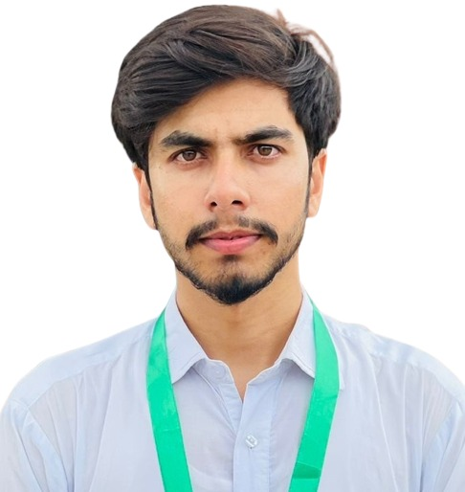 **SYED AHMAD ABBAS**

**BBA (SPEC-HR)**

Park Road Hostel City Islamabad



 +92333-5628491

 [ahmad5tanni@gmail.com](mailto:ahmad5tanni@gmail.com)

**OBJECTIVE**

To pursue my professional career in a dynamic environment where I can broaden my horizon by complementing my theoretical experience. To find place in an organization of repute and class that would provide me with the opportunity to fulfill my goals.

**EDUCATION**

|  |  |
| --- | --- |
| BBA (Spec-HR) | FUUAST ISB (2019-2023) |
| F.Sc. Pre-Engineering | BISE Kohat KPK (2017-2019) |
| S.S.C. Group Science | BISE Kohat KPK (2015-2017) |

**PERSONAL INFORMATION**

|  |  |
| --- | --- |
| Father Name | Syed Naeem Jan |
| Date of Birth | 05/03/2001 |
| CNIC No | 21603-1533859-9 |
| Gender | Male |
| Nationality | Pakistani |
| Religion | Islam |

**SKILLS**

**TECHNICAL SKILLS: CERTIFICATIONS: _______________**

* Leadership. MS Office (Mar 2017 - Sep 2017)
* Teamwork
* Report Writing
* Problem Solving
* Communication Skills
* Time management
* Ethics & Integrity

**PROJECTS**

* FEASIBILITY REPORT (PM)
* Touring Company (SME)
* Install a payroll software in a Small business
* employee Branding challenges and opportunities (an interview with HR professionals with experience in employees branding)

**WEBSITES & SOCIAL LINKS**

* Facebook: https://www.facebook.com/syedahmad.abbas
* Instagram: Instagram.com/syedahmad.abbas
* Twitter: <https://twitter.com/SyedAhm32272725?s=09>

**LANGUAGES**

* Urdu
* English
* Pashto
* Punjabi

**HOBBY**

* Technology
* Media
* Fitness
* Games

**REFRENCE**

* Reference available upon request

**WORK EXPERIENCE**

* Medical Billing at MTBC bagh Kashmir (From 28 July 2024 – present)
* HR assistant