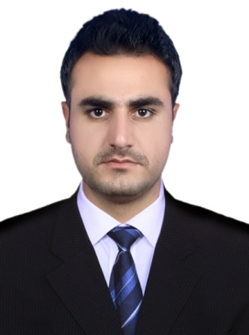

**LANGUAGES**

**Fluent In**

English

Urdu

Pashto

* Sharing legal information, tips and advice with work colleagues.
* Excellent problem solving and solution finding skills.
* Always respecting the differing needs, culture and values of clients.
* Drafting legal paperwork and material.
* Positive, confident and friendly demeanor with high level of integrity.
* Confident in presenting to decision makers in both public and private organisations.

**LLB** Islamia College Peshawar 1st 2014

**B.A (General)** Islamia College Peshawar 1st 2011

**HSSC (Pre-Medical) :** Peshawar Board 1st 2008 **SSC (Science) :** Peshawar Board 1st 2006

**ACADEMIC QUALIFICATIONS**

**KEY SKILLS AND COMPETENCIES**

**LAWYER 11-Feb, 2016 – Present**

Responsible for providing accurate and practical advice to clients on all legal aspects relating to their case.

Duties:

* Establishing what needs to be done to solve a client’s legal problems.
* Reviewing legal documents to ensure they are in proper format and contain all the necessary paperwork for court acceptance.
* Providing clients with legal advice and support on a wide range of legal issues.
* Representing clients in both criminal and civil trials.
* Attracting additional business from new and existing clients.
* Holding regular casework meetings and review with other legal staff.
* Reporting issues of concern to senior lawyers.
* Involved in drafting precedents and documents.
* Maintaining court dockets and diaries.
* Supporting clients across global sectors.
* Using specialist legal software to compile reports etc.

WORK EXPERIENCE

Father's Name : Momin Khan

Sex : Male

Nationality : Pakistani

Domicile : Mohmand

Religion : Islam

Date of Birth : 02-02-1992

C.N.I.C NO : 17102-1968869-1

PERSONAL INFORMATION

*Adress: Office 19-A, Chinar Building, Shuba Bazar, Peshawar.*

***Cell:-*** *+92-3459100463*  ***Email;- muhsinali.safi@gmail.com***

E:  [info@dayjob.co](mailto:info@dayjob.com)m

Corporate sector

International exposure

Legal research

Managing legal processes

Intellectual property

**AREAS OF EXPERTISE**

CONTACT

PERSONAL SKILLS

Attention to detail

Flexible

High energy levels

Multitasking

**MUHSIN ALI KHAN**

***Advocate High Court & Federal Shariat Court.***