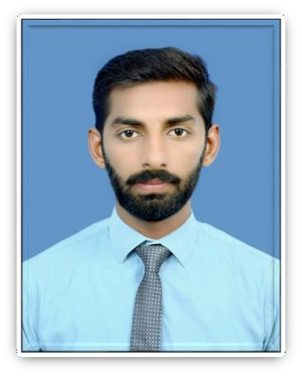

**MUHAMMAD**

**JUNAID**

**Contact**

**Address:**

1. House # 101 Firdous Colony (Firdous Hall-B) near Nibbah Road UAF.
2. Chak # 91 ASB Sargodha

**Father's Name:** Muhammad Nazir

**Date of Birth:** 08-08-1994

**CNIC** #: 38403-5303135-9

**Martial Status:** Married

**Religion:** Islam

**Phone:** +92-3467035332

**Email:** [Junaidgondal.927@gmail.com](mailto:Junaidgondal.927@gmail.com)

**Languages**

* + English
  + Urdu
  + Punjabi

**Hobbies**

* Traveling
* Photography

# Summary

To contribute to world profession and humanity with spare head field zeal and enthusiasm by employing character ethics of honesty, hard work, sincerity and devotion

# Skill Highlights

* Project management
* Marketing Research
* Customer relation management

# Experience

* Product development
* Team Management
* Expertise in all packages of Microsoft office
  + 4 year working experience as a Territory manager in Brookes Pharma (Metier group of companies)
  + 1.2 working experience in Suzuki falcon Motors Sargodha in cash Department.
  + 2 Year working experience in Happilac Paint as Sales officer.

# Education

* + - MBA (Marketing) from University of Sargodha in 2022
    - M.Com (Finance) from University of Sargodha in 2017
    - B.Com from University of Punjab in 2015
    - D.Com from P.B.T.ELahore in 2013
    - Matric from BISE Sargodha in 2011