Muhammad Saad

Father’s Name: Muhammad Zahid Kalim
Contact: +92 313-9420504



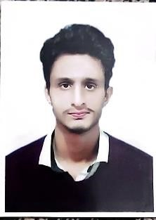
Email: saadzahid1998@gmail.com Address: House #78, Street #12, Road #5, GULBAHAR #2
PESHAWAR, PAKISTAN

OBJECTIVE
To be a part of a reputable organization where there is an exclusive environment, healthy competition with ample prospects of professional and technical growth, where I am exposed to all discipline and can enhance my knowledge and broaden my experience to the maximum.

ACADEMIC INFORMATION

Certificate / Degree Level | Board/University | Specialization / Major Subject | Passing Year | Percentage/ CGPA
CBT (Auto Mechanic) | GTVC |  | 2021 | Component
Bachelors | University of Peshawar | Arts | 2021 | 46%
Intermediate / HSSC | B.I.S.E PESHAWAR | Pre-Medical | 2018 | 47%
Matric / SSC | B.I.S.E PESHAWAR | Science | 2016 | 54.7%

COMPUTER LITERACY
- MS Office
- Typing Speed over 40 WPM
- Internet usage

KEY SKILLS AND COMPETENCIES

- Excellent customer service and interpersonal skills.
- Excellent Communication skills.
- Capable to work independently and as a part of a dynamic team.
- Attention to detail with great logical skills.
- Flexible, organized, and team oriented.
- Good assessment and problem-solving skills.
- Good decision-making skills.
- Can thrive in a continually changing environment.
- Able to work under pressure and to aggressive deadlines.
- Leadership qualities.

Experience
- Working at Gandhara University Peshawar as IT Assisstant

REFERENCES

Will be provided upon request

