CV MUHAMMAD NOOR | CURRICULUM VITAE 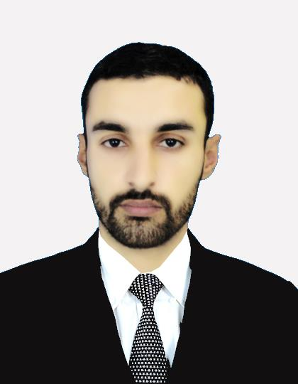  MUHAMMAD NOOR  E-mail: muhammadnoor189@gmail.com  Permanent address: Sector F-8 Street 11 House No. 161 Phase 6 Hayatabad Peshawar.  Contact Cell # : 0315- 5009933  0345-9126150
PERSONAL INFORMATION

- Father’s Name : Naranj Gul
- Date of birth : 05-03-1990
- Gender : Male
- Nationality : Pakistani
- Domicile : Parachinar
- Marital Status : Married
- Religion : Islam
- CNIC # : 21303-8971573-3
QUALIFICATIONS:
Degree | Institute | Marks/GPA | Session
Matric | BISE (Kohat) | 900 / 589 | 2007
D.Com (Part I) | NWFP Technical Board | 600 / 372 | 2008
D.Com (Part II) | NWFP Technical Board | 1200 / 733 | 2009
B.Com (Part I) | University of Peshawar | 700 / 373 | 2010
B.Com (Part II) | University of Peshawar | 1400/770 | 2011
MASTER IN HRM | University of  Peshawar | 4/3 | 2014

Experience:

- 2 Months Internship in HR Department of PTCL Peshawar.
- Working in Roryan Pharmaceutical (Pvt) Ltd Peshawar as an Accountant from 1 January 2015 to till date.
- Attended workshop of UNHCR by NRC (Norwegian Refugee Council) on 21st June 2012 on Guiding Principles on Internal Displacement.
JOB DESCRIPTION

TRIAL BALANCE CREATION FOR FINANCIAL STATEMENTS.
VOUCHING : CASH VOUCHERS, BANK VOUCHERS & JOURNAL ADJUSTMENT VOUCHERS.
BOOK KEEPING: BANK LEDGER, CASH BOOK, MAIN LEDGERS, SUBSIDAIRY LEDGERS.
CREATING DOCUMENTATION REGARDING BANK LEASE, OTHER OFFICIAL MATTERS.
MAINTAINENCE AND AUDIT OF ALL SORT OF LEDGER FOR ACCOUNT RECONCILIATION.
DATA ENTRY AND OTHER COMPUTER WORKS FOR OFFICE.
COMPUTER SKILLS

  - CIT (Certificate in information Technology) From Skill Development Council.
  - MS Office (Word, Excel, Power point) From Professional Skill development institute.

HOBBIES:

- Reading Books and Newspaper.
- To become part of a dynamic organization.
- Work on Computer.

LANGUAGES:

S/No | Language | Read | Write | Speak
1. | Pashto | Excellent | Excellent | Excellent
2. | English | Excellent | Excellent | Excellent
3. | Urdu | Excellent | Excellent | Excellent

REFERENCES:

References are available on demand.

