|  |
| --- |
| ***Muhammad luqman*** |

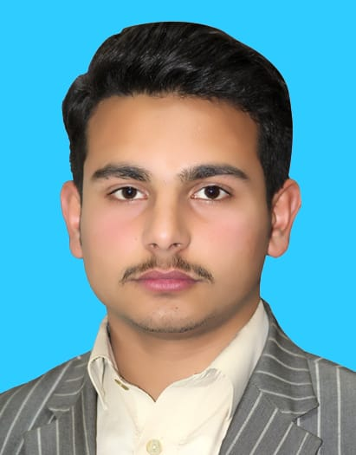***Mailing Address:*** *H # 04 St #01 Bajur Colony by Pass Road Mardan KPK Pakistan.*

***Permanent Address:*** *Village Seeni Abad P.O Box Hathian Tehsil TakhtBhai.*

***District****: Mardan*

***S/O:*** *Fazli Subhan*

***Contact:*** *+92-3481757587*

*+92-3159478395*

***Email:*** *luqmanseeni@gmail.com*

|  |
| --- |
| ***CAREER OBJECTIVE*** |

*To be a part of such a dynamic and progressive organization in which new opportunities and experiences are offered. Seeking a Challenging position that will ensure growth in my professional career and progress in organizational targets, A high-impact leadership position requiring creative and innovative approaches to problem solving, strategy development to meet the Objectives*

|  |
| --- |
| ***EXPERIENCES & SIGNIFICANT ACHIEVEMENTS*** |

***Quran Host Online Quran and Arabic Academy: September-2022 to Present***

***Senior Manager Customers Relations:***

Responsibilities:

* *Building and maintaining profitable relationships with key Customers.*
* *Overseeing the relationship with Customers handled by the team.*
* *Resolving customer’s complaints quickly and effectively.*
* *Expending the customer base by adding new customers.*
* *Assist sale team in business acquisition, plaining, retention and management.*
* *Maintain complete and accurate customers corresponding data*

***Sardar Raheem Traders(SRT): January-2022 to August-2022***

***Marketing &Recovery Officer:***

Responsibilities:

* *To develop new dealers and retailors*
* *Products / Electronic dispatch and store items management*
* *Managing customer’s feedback and queries*
* *Managing recovery targets within the given time*
* *Reporting and managing relations with potential customers*

***National Socio-Economic Registry (NSER): March-2021 to December-2021***

***Monitoring officer:***

Responsibilities:

* *Data Collection of BISP program*
* *Listing data in excel and online data feeding to server*
* *Interacting with local residents and collecting their data*
* *Reporting and managing the collected data*

|  |
| --- |
| ***CAREER SUMMARY*** |

*B.s (CS) software Abdulwali khan university Mardan (****AWKUM)*** *2018-22*

*FS.c (Pre-Engineering) B.I.S.E Mardan 2016-18*

*D.I.T (Information tech) KPITB 2018-19*

*S.S.C (Science) B.I.S.E Mardan**2014-16*

|  |
| --- |
| ***CERTIFICATES*** |

### MS OFFICE (D.I.T) :( 2013)

*MS Excel*

*MS Word*

*MS PowerPoint*

*MS Outlook*

|  |
| --- |
| ***SKILLS AND COMPETENCIES*** |

* *Good written, oral and interpersonal communication skills.*
* *Highly adaptable to work in challenging and competitive environment.*
* *Well-mannered with high sense of commitment, loyalty, integrity and patience.*

***IT Skills:***

* *Excellent Command on MS Office (All Versions).*
* *Windows (All Versions).*
* *Much familiar with Computer Hardware/Software installation.*
* *E-mailing through Outlook Express*
* *All Windows base application.*
* *Having good experience in video editing, photo editing.*
* *Having good knowledge about coding.*
* *Having god experience in web designing(PHP)*

|  |
| --- |
| ***PERSONALS*** |

* ***Interests:*** *Family, Hiking, Gym, Cricket, New ideas, Gaming & Internet surfing.*
* ***Born:***  *03 May 2000*
* ***Marital Status:*** *Single*
* ***Nationality:*** *Pakistani*

|  |
| --- |
| ***Languages Written Spoken*** |

* ***English*** *Fluent Fluent*
* ***Urdu*** *Fluent Fluent*
* ***Pashto*** *Fluent Fluent*

|  |
| --- |
| ***References*** |

*Will be furnished on request*