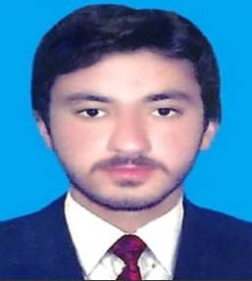

**CNIC No. 17102-6474958-9**

**Date of birth: 10-mar-1997**

Contact

**Address:**

Mohala Sahibzadgan VC Fatih khel Nusratzai Bazar Tehsil Tangi Distt Charsadda.

**Phone:**

+92-317 7896702

**Email:**

Sahibzadaiazazkhan@gmail.com

Languages

English

Urdu

Pashto

Read, Write, Understand

MUHAMMAD IAZAZ

Summary

To be the part of an organization that would provide me with an opportunity to apply my knowledge and skills and also the part of a team that would work dynamically towards the growth of the organization.

Skill Highlights

|  |  |
| --- | --- |
| * PCR Laboratory Expert * Excellent Comunicator * Complex problem solver | * Marketing Skills * Customer Developmet * Administrator |

Experience

**Hospital**

* 1 Year Experience as a lab administrator& PCR Expert in Pathology Dept Khyber Teaching Hospital Peshawar from 2017 to 2018.

Pharmaceutical:

* 1 Year Experience as STM in SJG Pharmaceutical from 2018 to 2019.

Area: HMC, LRH, Bara, Jahangira, Charsadda, Hayatabad

* 3 year Experience as SPSP in Ferozsons Laboratories from 2020 to 2023.

Area: North West, RMI, PGH, Life Care, HMC, Charsadda, Landi Kotal, Bara, NTH, Charsadda Road

Specialty: Urology, Orthopedic, Gastro, Rheumatology, Gynae, Medicine, General Surgery.

Education

|  |  |  |  |
| --- | --- | --- | --- |
| SSC | 2012 | 1st Div | Bisep |
| F.sc | 2014 | 2nd Div | Bisep |
| BS (Biotech) | 2018 | 2nd Div | BKUC |
| DIT | 2015 | 1st Div | BTE Pesh |

Certifications

* 1 Year Higher Diploma In Computer Science.
* 6 Months Mora Computer Training Certificate.
* 3 Months Computer Short Course.
* 1 Year Intern ship Certificate in Khyber Teaching Hospital Peshawar.