URRICULUM
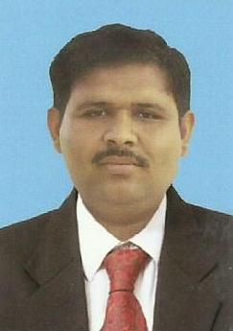
ITAE
Muhammad Abubakar

Cell: 0346-4152274
OBJECTIVE:

Seeking the opportunity where I would be able to best demonstrate my

Potential in highly competitive and enhance my professional skills.
PERSONAL PROFILE:

Father’s Name Muhammad Umer

Date of Birth 01-07-1995
CNIC 32304-4408683-5
Domicile Muzaffar Garh (Punjab)
Marital Status Single
Religion Islam
Nationality Pakistani
E-Mail muhammadabubakar7714@gmail.com
Language Urdu, Saraiki, Punjabi, English.
Address Basti Dhollain P/O Sharif Chhajrah Tehsil & Dsistrict Muzaffargarh
ACADEMIC RECORDS:

Degree | Years | Marks/CGP | Board/ University
M.com | 2017 | 3.03/4.00 | B.Z.U Multan
B.Com | 2015 | 1022/1500 | B.Z.U Multan
D.Com | 20013 | 887/1200 | PBTE Lahore
Matric (Science) | 2011 | 803/1050 | BISE DG Khan
EXPERIENCE:

- 5 Month teaching as CTI
- Network administrator
- Web Designing
- MS Office
- Internet Browsing
- C.C.A 6 Month course

OTHER ACTIVITIES:

- Reading Books
- Reading Newspaper
- Discussion on Current Affairs
REFERENCE:

Reference will be provided on demand

