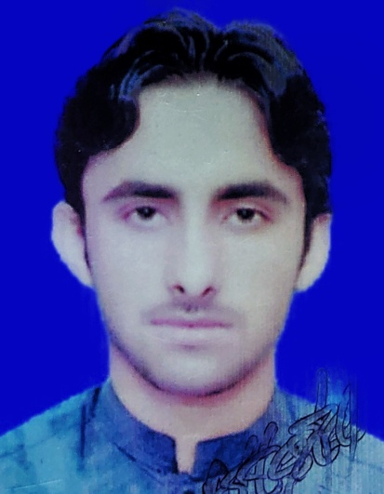
RESUME
MOHAMMAD IKRAM

- Current Address : Jamrud Kharki Abad
- Postal Address : Jamrud Kharki Abad District of Khyber
- Contact No : 03085580611
- Gmail : ikramafrid008@gmail.com

OBJECTIVE

ssssss
I would dedicate myself towards the achievement of company’s objectives while being a part of it and would carry out my duties responsibility, while maintaining excellent interpersonal relationships with my fellow workers.

PERSONAL DETAILS

- Name : Mohammad Ikram
- Father’s Name : Mabood Khan
- C.N.I.C : 21202-1161220-1
- Date of Birth : (09-03-2002)
- Religion : Islam
- Marital Status : Single
- Domicile : Khyber (KPK)
- Nationality : Pakistani

ACADEMIC QUALIFICATION

Degree | Division | Year | Board/University
Matric (Science) | 1st | 2016-2017 | Peshawar Board.
FSc Pre-Medical | 1st | 2018-2019 | Peshawar Board.
Bs (Commerce) | ^{1st} | 2020-2024 | Peshawar University.
DIT | 1st | 2020 | KPK BOARD of TECHNICAL EDUCATION
LANGUAGE

Urdu, Pashto & English

EXPERIENCE

NO

