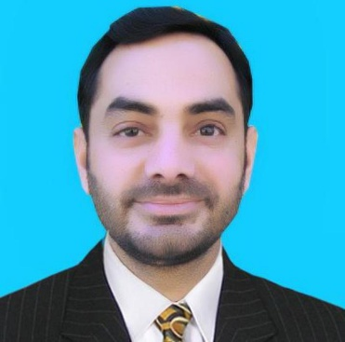 **MUHAMMAD SOHAIL**

**Cell & WhatsApp No: +923009032810**

**E-mail: muhammad.sohail105@outlook.com**

**Charsadda kpk**

**CAREER OBJECTIVE:**

Seeking a challenging career in an esteemed organization where my talents can be utilized for the growth of the company as well as self in an environment where team player role is significant and to be best, be considered as an asset by employer. Learn, gain and implement.

**EDUCATIONAL QUALIFICATION:**

* **B.A** (Bachelor Degree of Arts) 2012
* **F.A** (B.I.S.E Peshawar) 2009
* **S.S.C** (B.I.S.E Peshawar) 2006
* **One year Diploma in computer, word, excel, PowerPoint and internet.**

**WORKING EXPERIENCE:**

* + Worked as a **pharmacy store clerk** in **PHARMA LIGHT MEDICAL STORE** AT **MEDICLINIC MEIDDLE EAST** from 22 march 2016 till 30 October 2019.
  + Worked as a **FAMILY DRIVER** from Feb ,2015 to till feb 2016 in Dubai –U.A.E
  + 4 years worked as a **SALESMAN** in **MOBILE AND COMPUTER REPAIRING AND SALES SERVICES**, charsadda, Pakistan
  + Two years Worked in a **PHARMACY** as a salesman in Charsadda Pakistan

**PERSONAL DETAIL:**

* Date of birth : 20-02-1989
* Marital status : Married
* Nationality : Pakistani
* Religion : Islam
* Languages Known : English, Urdu & Pashto, Arabic

**LICENSE DETAIL:**

**Holding Valid U.A.E Light Driving License** (Dubai)

License No : 3414979

Date of issue : 02-02-2015

Date of expiry : 09 Feb 2025

Vehicle Permitted : 3

**PASSPORT DETAIL:**

* Passport No : EK5197851
* Date of Issue ظن: 11-01-2022
* Date of Expiry : 10-01-2032

**SKILLS:**

* + Flexible determined and committed to achieving organizational objectives.
  + Continually improving services and system knowledge
  + Excellent problems solving skills