**OBJECTIVE**

To work in a dynamic and challenging environment of good recognized Organization with seeking a position in a reputable growth oriented organization where i can utilize my expertise & experience.

**EXPERIENCE**

**Planet Textile Industries.(Manufacturer & Exporters)**

**(FAISALABAD)**

**ACCOUNTS OFFICER**

(25-06- 2021 TO 28-06-2023)

**Transaction Management:**

Recorded and managed diverse financial transactions specific to the textile sector, ensuring accuracy in procurement, production, and sales.

**Inventory Accounting:**

Maintained detailed records of inventory transactions, optimizing tracking for raw materials, work-in-progress, and finished goods.

**Cost Analysis:**

Conducted precise cost analysis for textile production, contributing to effective cost control and pricing strategies.

**ERP System Expertise:**

Utilized Oracle ERP for seamless integration of financial processes within the textile production and sales cycle.

**Regulatory Compliance:**

Ensured compliance with textile industry taxation regulations, particularly in sales tax on finished goods.

**Collaboration with Supply Chain:**

Collaborated closely with supply chain teams, aligning financial processes with procurement and production needs.

**Financial Reporting for Textile Operations:**

Prepared detailed financial reports specific to textile operations, providing valuable insights into the financial health of the business unit.

**CONTACT**

**Address:**

House No 155/2 Mohalla Islamabad City Kundian Distt (Mianwali)

**Phone & WhatsApp:**

+92 3164148944

+92 3237748222

**Email:**

Mahadali7748@gmail.com

**LANGUAGES**

ENGLISH

URDU

PUNJABI

SRAIKI

MUHAMMAD

MAHAD ALI

ALI

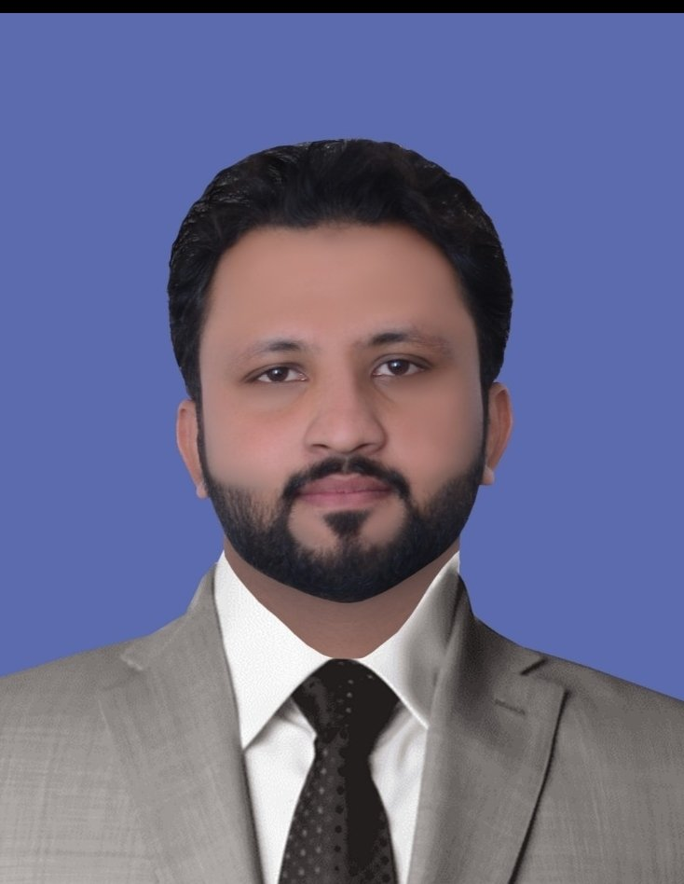

**Mobiserve Pakistan Pvt Ltd (Multinational)**

**(ISLAMABAD)**

**Specialist (Payroll)**

(03-07-2023 To 31-12-2023)

**Duties & Responsibilities**

* **Implements, maintains & review timely processing of payroll, including salaries & benefits approval taxes & other deduction**

1. Verifying staff by conducting payroll verification.
2. Updating new hires & terminations.
3. Allowances consolidation & approval.
4. Update salary changes after necessary approvals.
5. Maintain accurate records & reports of payroll transactions.

* **Employee bank accounts.**

1. Following up, Collecting & verifying bank account numbers of new hires.
2. Verifying account status from banks (HBL, other networks & Easy Paisa).
3. Replying to discrepancies & following up to get accurate account numbers.

* **Employee separation management.**

1. Reviewing & approving employee’s separation by Flow HCM.
2. Follow up & approving termination, show cause notice & downsizing letters.
3. Reviewing exit interview feedback.

* **Employee final settlement.**

1. Sending NOC to concerns by Flow HCM.
2. Preparing & verifying employee final settlements.
3. Employees leave balances encashment.
4. Preparation of f/s voucher & sending to finance for payment.
5. Voucher entries in oracle.

**Others Responsibilites**

* Following up with all concerned for f/s clearances by eflow.
* Responding & resolving ex-employees queries related to their f/s.
* Updating F/S log sent to finance for cheque preparation & pending at finance.
* Sending signed cheques to regional offices.
* Following up to receive signed voucher back.
* Conducting exit interviews, having questions (Reason for Leaving Job, Where new Job, New Salary & their feedback about Mobiserve Pakistan).
* Following up queries with concerns in the region.
* Conducting welcome calls.
* Guiding employees to use mobile application for attendance, (grievance reporting).
* Preparing experience letters for NOC cleared employees.
* Preparing Reference letters for employees.
* Attending calls from employees.
* Responding to employees queries after getting relevant feedback from team.

**Dr. A.Q Khan Institute Of Technology**

**(MIANWALI)**

**ACCOUNTANT**

(13-02-2024 To Continue)

* Maintain accurate financial records, including accounts payable, receivable, payroll, and general ledger entries.
* Prepare monthly, quarterly, and annual financial reports for college administrators and regulatory authorities.
* Assist in developing and monitoring the college budget, ensuring departmental compliance.
* Coordinate financial audits and ensure adherence to accounting standards and policies.
* Manage cash flow, banking relationships, and make recommendations for investment activities.
* Conduct financial analysis to support strategic decision-making and long-term planning.
* Provide training and support to college staff on financial policies and procedures.
* Oversee vendor relationships and procurement processes

**QUALIFICATION**

**DegreePassed YearBoard/University**

BBA-Hons (4years) 2021 University Of Sargodha

Intermediate D.Com 2017 PBTE Lahore

Matriculation (Science) 2015 BISE Sargodha

**CERTIFICATIONS**

2 Year Computer Certificate in MS Office from **GCC**

**COMPUTER SKILL**

• ERP ORACLE

• Proficient in using Microsoft office.

• Internet Browsing

• Software installations & Hardware Management

• Proficient Typing speed in English

* Flow HCM

**PERSONAL PROFILE**

• Father’s Name Ghulam Muhammad

• Date of Birth 20-June-1998

• CNIC No 38303-9718837-3

• Religion Islam

• Marital Status Single

• Nationality Pakistani

**REFRENCE**

Reference will be provided on demand.