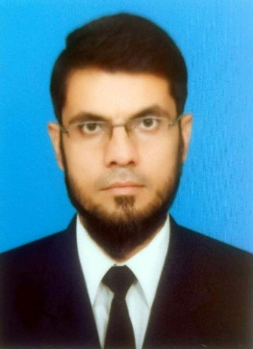CURRICULUM VITAE

## Amir Rizwan

# Educational Qualification

MBA (Human Resource Management)

GPA 3.7out of 4.0

From Preston University Kohat

Passing Year 2011

MS Office (6 months Diploma from U &U software Institute)

# **Career Objectives**

To associate with vibrant organization which allows me to put my competencies to the best use and add value to the organization contributing to growth as an individual.

# Personal Strength:

•Communication Skills, Good managerial skills.  
•Confident, Optimistic.  
•Love to learn new things & detail conscious

# Professional Experience

1. 02 years as HR & Admin Officer in Ujala Welfare Organization Kohat

2. 8 months as Admin & HR Officer in International Human Rights Organization Islamabad

3. 08 Years as Admin Officer with Property And Builders APPL ISLAMABAD

4. Currently working As HR and Admin Officer at BUTT Paints Industry Lahore.....

# Career summary

- Experience of manpower management, recruitment involving resume generation, screening, and

short-listing and salaryfitments.

- Adept at people management, maintaining healthy employee relations and handling employee

grievances thus creating an amicable & transparent environment.

- Skillful in implementing HR systems and policies, conducting training programs towards enhancing

employee productivity and building committed teams.

- Ability to motivate personnel towards achieving organizational objectives & adhering to industry

best practices.

- Possess strong communication, interpersonal and relationship management skills.

# **Personal information**

Father name: Flt.Lt (Retd) Nasir Ali Khan

D.O.B: 1st Oct 1986

Domicile: Karak

Citizen: Pakistani

Martial Status: Married

CNIC # 14202-5908259-7

Cell # 03400937370

Address:

Mailing Address: House # 100, Park Lane Society, Tayaba Garden,Street # 4,

Sharaqpur Road, Lahore

Permanent Address: Village Shaheedan Banda, P/o Jandrai, Tehsil and Dist.

Karak