CURRICULUM VITAE
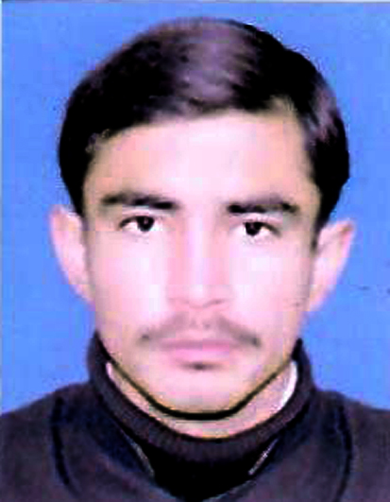
Father Name: Israr Khan
Date of Birth: July 13, 1995
Nationality: Pakistan
Religion: Islam
Native Language: Pashto
Mobile Number: +92 (0) 332-9120211
CNIC No: 17301-4152673-5
E-mail Address: Izharullah116@gmail.com

Present & Permanent Mohallah, Aftezai, Village, Regi, District-Peshawar-Pakistan.
Domicile: Peshawar (KP).

Postal Address: Mohallah, Aftezai, Village, Regi, District-Peshawar-Pakistan.

IZHAR ULLAH

CAREER OBJECTIVE:

To analyze a challenging position in an organization, where its members believe in common vision, teamwork and respect for each other.

EDUCATION:

SSC (Science) 2011 57% BISE Peshawar

FSc (Computer Science) 2013 51% BISE Peshawar

BBA (Hons) 2017 64.7% Islamia college University Peshawar

MS 2022 process Islamia college University Peshawar

SPECIALIZATION:
Specialization in Human Resources Management (HRM).

PROFESSIONAL EXPERIENCE/ PRACTICAL TRAINING:

- Eight weeks (02) months as Internee in ZRK Group of industries (Pvt.) starting from 26th May to 31st
July 2017. Also, complete the practical training to 31st July 2017.
- Currently working in Mazhar Enterprises (Pvt) ltd Peshawar as HR assistant start from 16 September 2017 Mazhar enterprise pvt ltd handle the software projects in AJK
- First shift time work in Islamia children academy school as a accountant or office assistant.
- Second shift time work in Mazhar Enterprises pvt ltd
- So the over the experience is 10 month and 7 years

COMPUTER SKILLS:

- Windows XP, MS Office (MS Word, MS Excel, MS Power Point, MS Access)
MS Outlook Express, Internet etc.

LANGUAGE PROFICIENCY:

Speaking Reading Writing
Pashto Good Good Good
Urdu Good Good Good
English Good Good Good
REFERENCES:
References will be provided when required.

