Mr. MUHAMMAD IRFAN KHAN
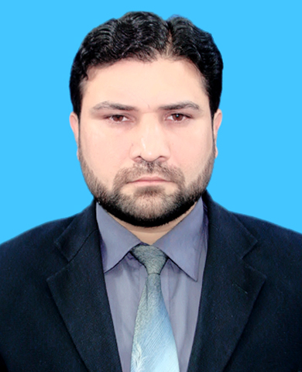
MBA (FINANCE) MS Equalent by HEC.
BBA (Hons) 4 Year (FINANCE)
Postal Add: Gul House Beside Govt Girl Primery
School Sohrab Gul Korona,near parao bazar cherat
Road, Nowshera PAKISTAN.
Phone Res. 03339114686
Mobile: 0092-333-9156121, 0342-5612242
E-mail:khanirfan1@gmail.com
Skype ID: irfankhanuet
OBJECTIVES:

To make effective use of my Financial background in the field of Finance and Administration in well renowned organizations. I accept challenging task based on MBO environment and I would like to work in a dynamic and progressive organization.

My Vision and Belief:

To be successful I’ve got to have a dream, a vision, a burning passion, a magnificent obsession. This dream, goal, obsession has to become my prime motivator. It takes enthusiasm, commitment, pride, a willingness to work hard, a willingness to go the extra mile, a willingness to do whatever has to be done in order to get the job done.

AREAS OF KNOWLEDGE

- Financial Management
- Financial Analysis
- Reconciliations
- Financial statements
- Accounting Books
- Budgeting/ Financial Projections
- Internal/external Control

PERSONAL PROFILE:

I have more than 15 years of extensive experience with proven of success record in private sector. During my employment I have learned the ability to have vision and conceptualize long term perspective, ability to manage many tasks simultaneously with a strong attention to details, excellent interpersonal and management skills.
I am well-composed, energetic, dedicated and enthusiastic person having dynamic personality with strong interpersonal skills, highly self motivated and responsible professional, task oriented.

PERSONAL INFORMATION

Father’s Name : MOHIB GUL (KHATTAK)
N.I.C No : 17301-1438227-9
Passport No : AR4102271
Date of Birth : 17-May-1984
Martial Status : Married
Religion : Islam
Languages : English: (Speak, Read and Write fluently)
Urdu : (Speak, Read and Write fluently)
Pashto: (Speak and Read fluently)

EDUCATION

Masters of Business Administration (Finance) 2008- 2010 3.40/4.00 CGPA
(IMS) Institute of Management Studies
University of Peshawar

Bachelors of Business Administration (Hons) (Finance) 2004-2007 3.60/4.00 CGPA
(IBMS)Institute of Business and Management Sciences
KPK Agricultural University Peshawar

FSC (Pre-Engineering ) 2001-2003 1st division
Peshawar Public School & College
Warsak Road Peshawar.

SSC (Science Group) 2000-2001 1st division
Peshawar Public School & College
Warsak Road Peshawar.

EXPERIENCE

- FWO Frontier Works Organization since 26 Dec 2017 to Date
Junior Manager Finance

- Al- Nasir Marble Factory April 2016 to sept 2017
Accounts Manager

- MONEY LINK EXCHANGE (PVT) LTD
Admin/Assistant Finance Manager 11 April 2011 to March 2016

- NASEER AHMAD & BROTHERS (Imp & Exp Clearing Forwarding Agent)
Account Officer 1st June 2010 to Jan 2011.

- UET (University of Engineering & Technology) peshawar.
Internee Accountant 1st June 2009 – 30 May 2010

- MALIK EXCHANGE (PVT) LTD
Assistant Finance officer 17st Dec, 2007 – Jan 2009

INTERNSHIP
National Bank of Pakistan Main Branch Peshawar Cantt: (0386) KPK
(Pakistan) from Aug 15, 2007 to Sep. 30, 2007. Concentrated in studying the operational work in the following Areas.

- Advances & Foreign Exchange Sections
- Account Opening
- Remittances
- Deposits
- Billing Section

COMPUTER SKILLS:
I have the skill to operate Computer Software’s & Programs:

- Certificate in Information technology (CIT – 6 month)
- MS Windows XP/MS Windows 7
- MS Office 2007/2003/2000
- Able to use a number of packages including, internet browsing, Accounting Software and other application software

ACHIEVEMENT / AWARDS

. Got Top ten scholarship in IBMS Agricultural university Peshawar.
. Got 1st position in the Home Exame
. Got Certificate of College Football Final Match.

REFERENCES:

Kaiwan Javid Muhammad Fayaz Aziz
Finance Manager Finance Manager
FWO Peshawar Cantt. Money Link Exchange Compy
Mob : 0321-38418938 Mob: 0333-58888394

