CIRCULLIUM VETAE

**IKRAM KHAN** 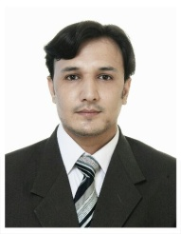

House 221, Street N0:10, Mobile#03459031177

Sector E3, Phase 1, 03159971155

Hayatabad [ikram.khan1@hotmail.com](mailto:ikram.khan1@hotmail.com)

Peshawar.

## Objective

To obtain such a position that offers growth, challenge, and career opportunity and enhances my organizational, personal and technical skills through hard working in a dynamic and challenging environment.

**Area of Interest**

* My area of interest is system & Network administration in windows, especially in the networking field and management of servers on the Windows.

## Educational Profile

* **B.S.C** computer science from GOVERNAMENT DEGREECOLLEGE HAYATABADPESHAWAR in 2010.
* **DAE** Examination from GOVERNAMENT COLLAGE OF TECNOLOGY PESHAWAR in 2007.
* **SSC** Examination from KHALIL MOHMAND CAMBRIDGE SCHOOL in 2003.

## Experience

* Currently working as a **Computer Desktop Support Engineer at DARAZ**.
* I worked as a **Computer Desktop Support Engineer** at Standard Chartered Bank for up to 7 years.

## Diplomas/Certificates

|  |  |  |
| --- | --- | --- |
| **Diploma/Certificate** | **Year** | **Institute/ Organization** |
| **MCSE** (MICROSOFT CERTIFIED SYSETM Engineer) | 2011 | NSIT INSTITUTE Peshawar. |
| **MCITP**(MICROSOFT CERTIFIED IT PROFESSIONAL) | 2011 | NSITPeshawar . |
| **CCNA** (CISCO CERTIFIED NETWORK ASSOSIATE) | 2011 | NSIT Peshawar. |
| **CCTV** (CLOSE CRICUIT TELEVISION) | 2011 | NSIT Peshawar . |
| **CIT** (Certificate in Information Technology) | 2004 | AL-NASIR computer institude. |

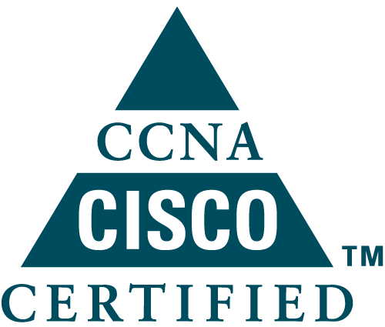

**Responsibilities**

* To manage/troubleshoot the desktops, laptops, printers, scanners and other small system devices present in the network.
* Interaction with end users (i.e. employees of Government departments) to provide support regarding network related issues like connectivity with servers, PCs and other equipment’s on the LAN.
* Fully assembling maintenance and troubleshooting of computers Hardware & Network accessories.
* Installation and management of **Active Directory, DHCP, FTP, DNS, ISA Server, Exchange server** etc.
* Installation of Different Software and Drivers etc.
* To manage/troubleshoot the desktops, laptops, printers, scanners and other small system devices present in the network.
* Interaction with end users (i.e. employees of Government departments) to provide support regarding network related issues like connectivity with servers, PCs and other equipment’s on the LAN.
* Fully assembling maintenance and troubleshooting of computers Hardware & Network accessories.
* Installation of Different Software and Drivers etc.
* **CCTV** (Closed Circuit T V).
* Smoke Detector.
* U P S (Uninterruptible l Power Supply).

**Skill Sets**

* LAN / WAN / Wireless design, implementation, and troubleshooting including Ethernet, Cisco switches, Routers, PIX/ASA Firewall, VPN Concentrator and IDS.
* Cisco Catalyst Switches Series **1900, 2900, 3550,5500,6500**
* Cisco Routers Series **1700,2500,2600,3600,4000,7200,7500**
* TCP/IP Protocols such as SMTP, DNS, SSL, SSH and Routing Protocols like **RIP, IGRP, EIGRP, OSPF, ISIS, BGP and MPLS.**
* Installations and Configurations of **Windows 2012 Server**, **windows 10, Windows 11,.**

**Networking Skills**

Network Administrator in Windows Win7 Win 10 Win 11 (Home edition, Multimedia Edition, Professional Edition) Windows Server 2012 and 2008 (Web Edition, Enterprise Edition, Standard Edition)

**Graphic Skills**

Graphic Designing in Adobe Photoshop, Corel Draw, power point and Some Animation in Flash.

**Hardware Skills**

Marinating of Hardware, Installing of Every kind of Windows & any other Operating System, Hardware trouble shooting. Installation of Any Type of Printers, Scanner, Biometric Devices Etc.

## Personal Profile

|  |  |  |
| --- | --- | --- |
|  | Name: | Ikram Khan |
|  | **CNIC No :** | 17301-0646525-5 |
|  | **Date of Birth :** | 20/06/1987 |
|  | **Gender :** | Male |
|  | **Religion:** | Islam |
|  | **Marital Status:** | Married |
|  | **Permanent Address:** | House N0 221, Street N0 10, Sector E3, Hayatabad Peshawar. |

## Co-Curricular Activities

* Creativity, Problem Solving, leadership. Able to meet deadline.
* Ability to work independently as well as with team.
* Producing innovative yet practical solutions to challenging problems.
* Good Mathematical and Communication skills.
* Highly motivated and active in social activities, volunteer ship and scouting etc.
* To find and learn the latest (New) Software’s of Different types.
* Surfing the Internet and Listening Music.
* **LANGUAGES:** 
  + - 1. Pashto
      2. Urdu
      3. English