Curriculum Vitae of



IMTIAZ KHAN

Address:
Aziz Abad Zando Banda Nowshera
Khyber Pukhtoonkhwa Pakistan.
Cell# 0333-9171450
Email: khanafridi593@gmail.com

OBJECTIVE:

To become a part of a dynamic group where I could further explore the skills and capabilities to server in a challenging work environment and to gain equally vast opportunites of career development based upon achievenments and result.

PERSONAL INFORMATION:

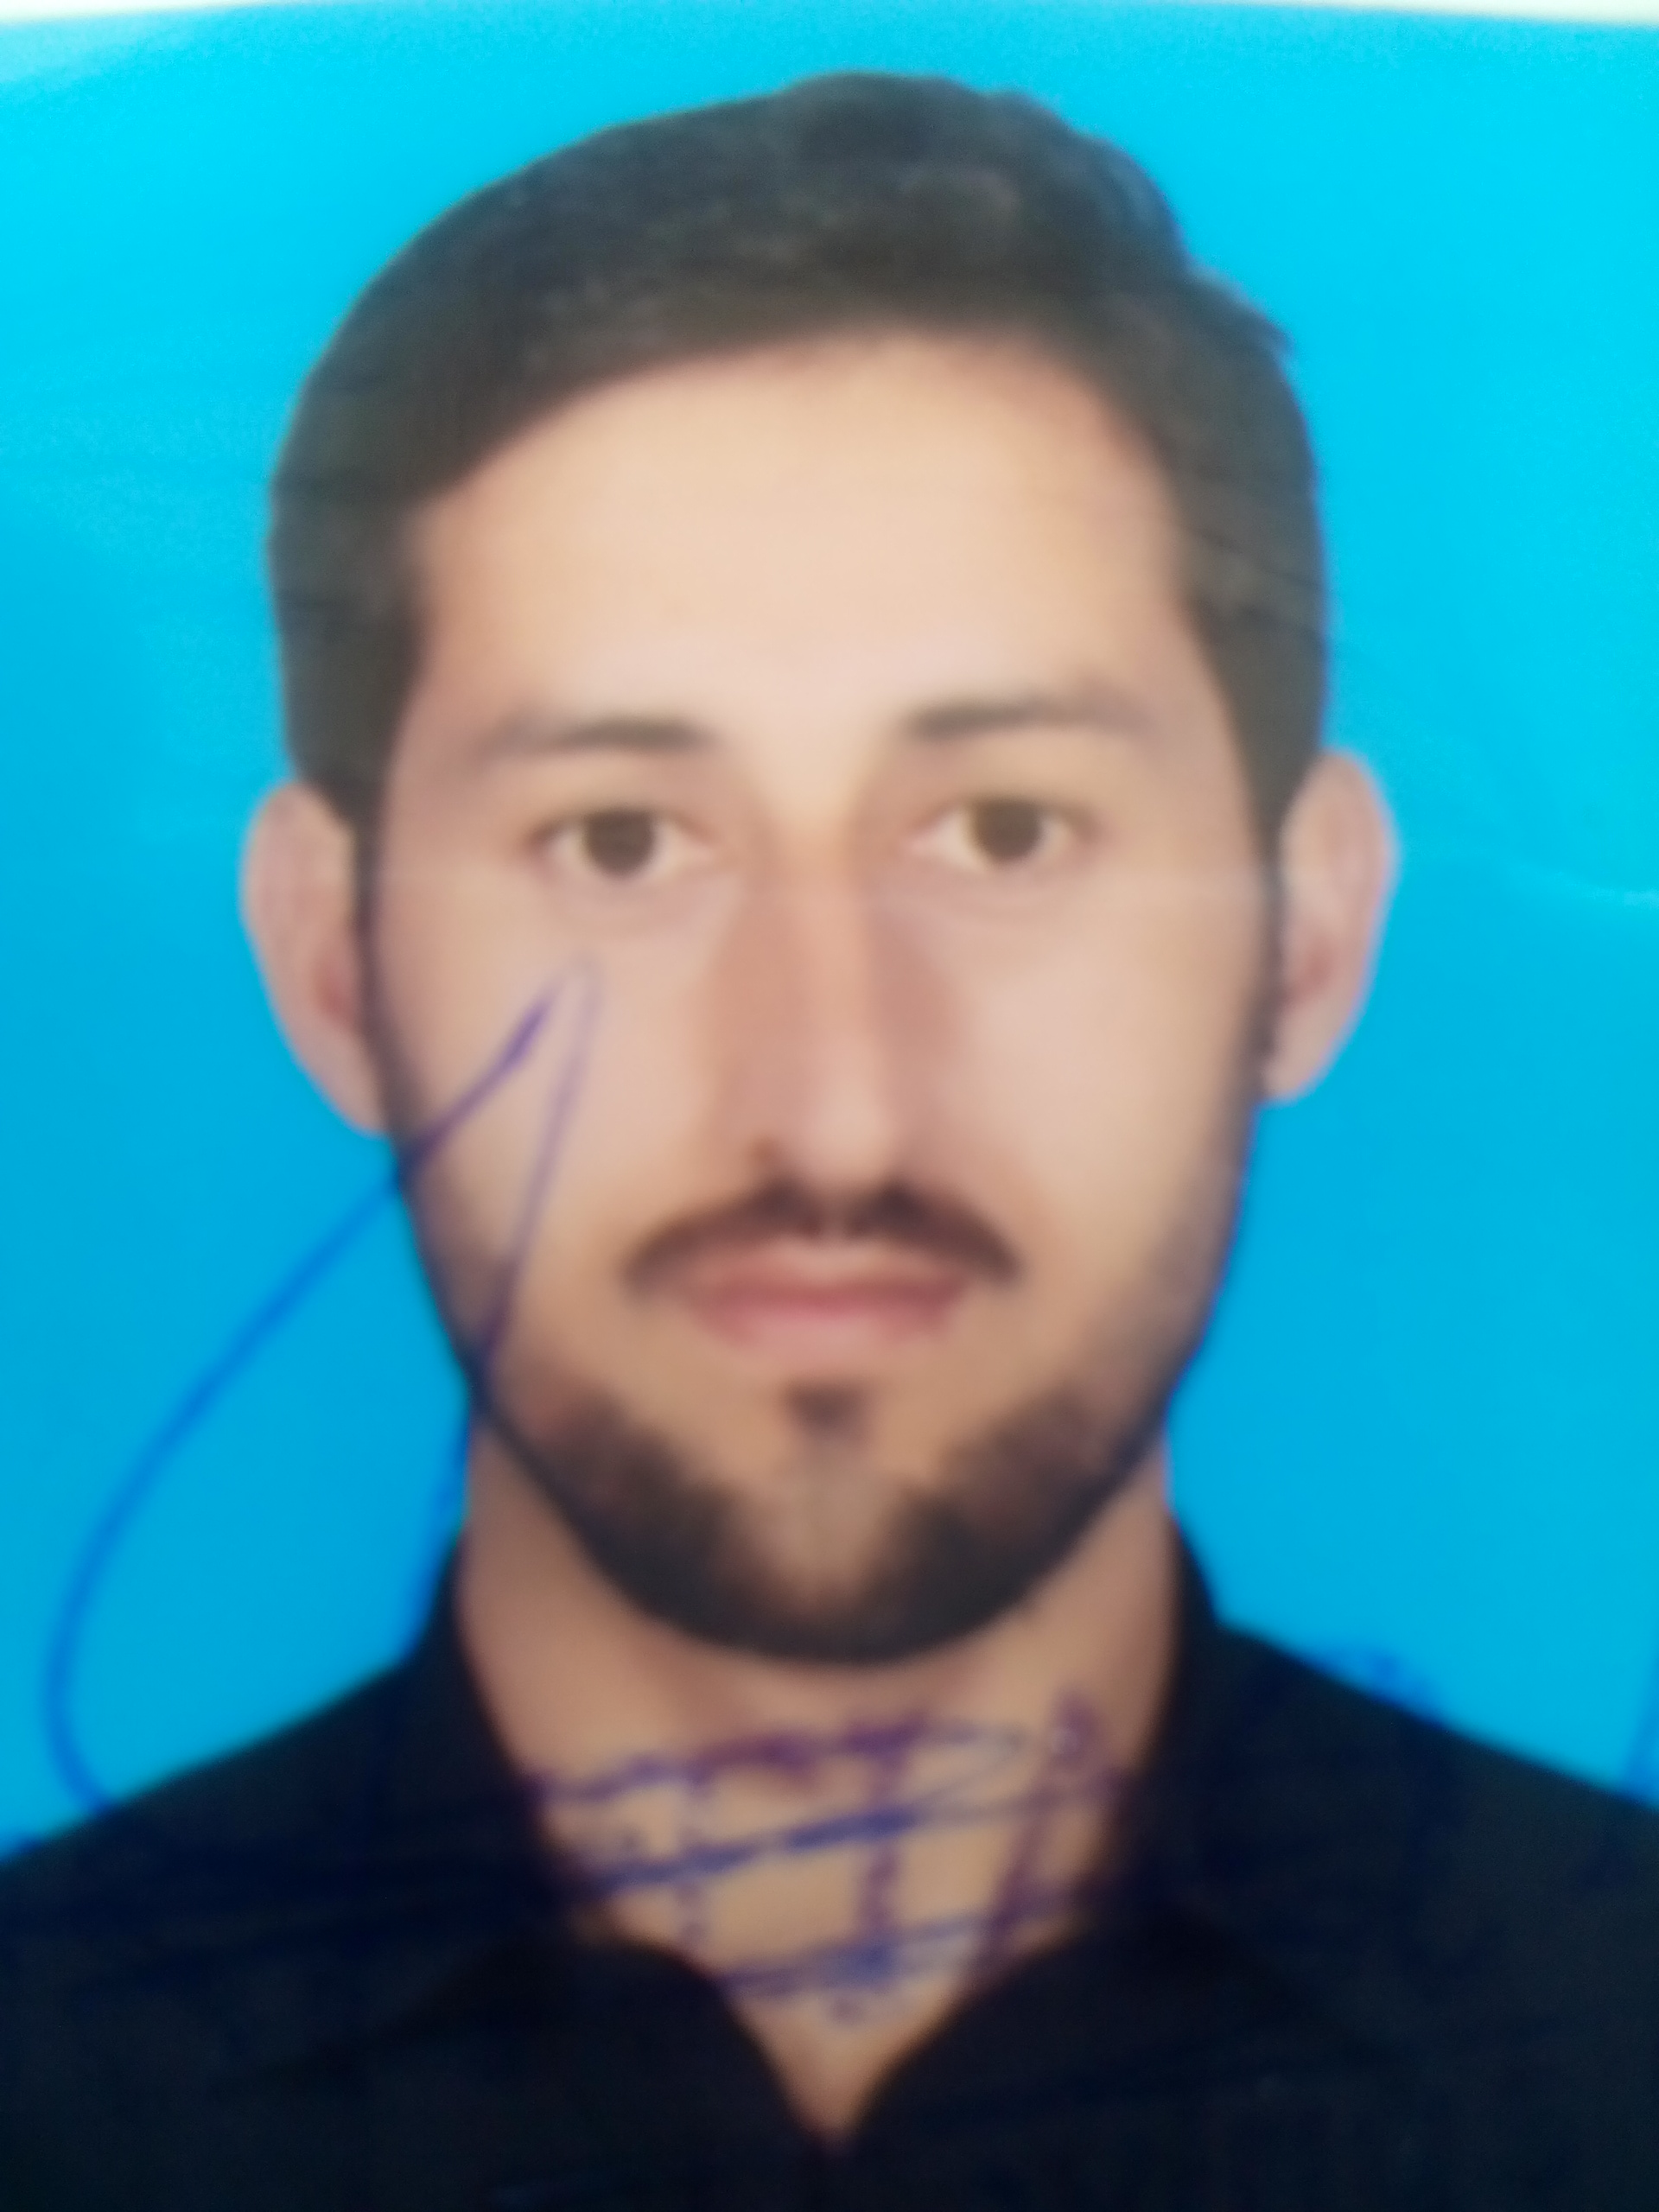
- Father Name: ZARBAT KHAN
- Date of Birth 01-02-1988
- CNIC #: 17201-5308312-9
- Domicile: Nowshera (KPK)
- Gender: Male
- Marital Status: Married
- Religion: Islam
- Nationality: Pakistani

ACADEMIC QUALIFICATION:

Degree/Certificate | Year | Obt Marks | Board/University
Matric | 2005 | 516/1050 | BISE Mardan
F.A | 2008 | 539/1100 | BISE Mardan
BBA (Finance) | 2012 | 1280/2000  (CGPA 2.87) | Northren Universty Nowshera
MBA (3.5 HRM) | 2016 | CGPA 3.20 | Abdul Wali Khan University Mardan

PROFESSIONAL Experience:

- Six years Experience as a Cost Accountant Having Hands-on Experience in SAP Software at ZRK GROUP Mardan till now.
- One Year Experience as an Accountant in National Internship Programe (NIP) at UBL Nowshera.

COMPUTER SKILL:

- Excellent official use of MS Office
- Good knowledge of Computer hardware and accessories repair and maintenance
- Excellent knowledge of internet, emailing, file uploading and downloading
- Have a good typing speed

LANGUAGES:

- English
- Urdu
- Pashto

