**CONTACT**

+92-3075950579

i

+92-3118717335

091 5838000- Ext 3198-3199

House 13 Umar Farooq Road Lalazar Colony University Campus Peshawar

[hamzanoor561@gmail.com](mailto:hamzanoorzong@yahoo.com)

**HAMZA NOOR**

**OBJECTIVE**

Seeking a career with a suitable job according to my Qualification and ability, this will provide me the platform to become a well-recognized professional. Ultimately attaining prestige and pride for the organization and myself.

**EDUCATION**

## PERSONALINFO

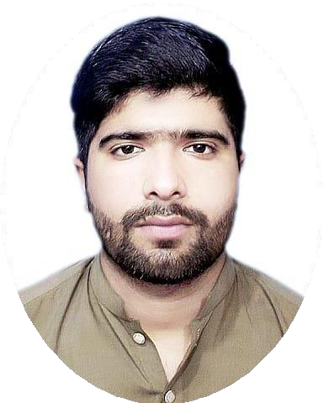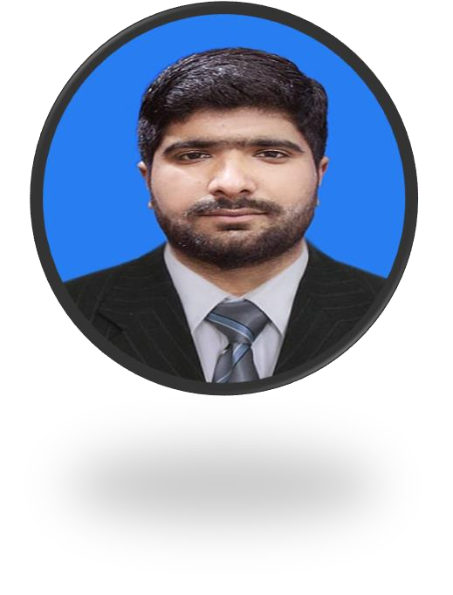

**FATHER NAME : Noor Ul Malik D.O.B : 05-03-1996**

**CNIC NO : 17301-5713932-9**

**DOMICILE : KPK**

**NATIONALITY : Pakistani RELIGION : ISLAM MARTIAL STATUS : Single GENDER : Male**

## LANGUAGES

* English
* Urdu
* Pashto

## HOBBIES

* Reading
* Writing
* Playing

## STRENGHTS

* Punctual
* Positive Attitude
* Good Communication Skills

|  |  |  |
| --- | --- | --- |
| **Qualification** | **Marks/CGPA** | **Board/University** |
| **SSC** | 570/1050 | BISE PESHAWAR |
| **HSSC** | 594/1100 | BISE PESHAWAR |
| **BBA (Hons) in Specialization(HRM)** | 2.91/4.00 | University of Agricultural Peshawar |

# COURSE

* 6 Months Diploma Certificate in Computer Course.
* 1 Month Internship as Franchise Post Officer at Pakistan Post Office.

# COMPUTERSKILLS

* + Writing 30 words per min at typing tutor or Ms office. Computer experience in different Software's etc.
  + Windows, MSOffice

# EXPERIENCE

* + 1 Year Experience as **Data Entry Operator** at lslamia Book Bank Peshawar.
  + 1-year Experience as **Supervisory Management** at Tent Service Peshawar.
  + 8 Months Experience as **Ware House In-charge** at ICELL Mobile phone accessories Company Peshawar.
  + Now Serving as **Supply Chain Officer (Store Officer) in Retail Pharmacy Warehouse** from 30 March 2022 to till dateat **Rehman Medical Institute**.

Following Responsibilities are as under.

* Receiving Medicine Stock in CRP.
* Check Batch No & Expire Date of Stock.
* Make GRN (Goods Receiving Notes) of Received stock.
* Issue Stock to Different Pharmacy Location from Warehouse.